Steps to Monitoring DSPy-Qdrant Powered RAG with Prometheus or Grafana

# Introduction

To keep your ML model sharp and fit for real tasks, keeping your eyes on it is a must. Devs, therefore, need to plug in solid watch tools.

Here we dive into tracking a RAG pipeline made with Qdrant and Mistral-7B; we'll use Prometheus and Grafana for this task. This walkthrough will guide you through setting up monitoring tools for your RAG workflow.

This will help you visualize how your ML workflow is performing in real-time. In production environments, this is a vital component. Developers tasked with ensuring reliability of their solutions need to embed top-notch monitoring solutions deeply within the infrastructure of these models.

This is why our focus will be on harnessing Prometheus and Grafana as part of our monitoring toolkit. Let's get started.

# Introduction to Retrieval-Augmented Generation (RAG) Pipeline

RAG enhances the output quality of language models by first retrieving relevant information from a large database and then using this context to generate responses. Why does it stand out? It draws on actual, gathered data for responses, not merely internal knowledge that the LLM was trained on.

For people already working in AI, you must know about vector stores. Today we are going to use [Qdrant](https://qdrant.tech/).

# Overview of Qdrant and Mistral 7B

#### Qdrant

Qdrant excels as a vector search engine, swiftly finding similar items through vector similarity within massive datasets. It stands out because of features like sharding, multi-tenancy, geospatial support, scalability, and it is open source and has been written in Rust. At the heart of our RAG framework, it serves as the engine, retrieving essential documents or pieces that supercharge our language model's generation capabilities.

The integration of Qdrant with Mistral 7B to set up a RAG stack involves several key steps:

#### Data Preparation and Indexing

For this article, I will be using <https://huggingface.co/datasets/Malikeh1375/medical-question-answering-datasets>

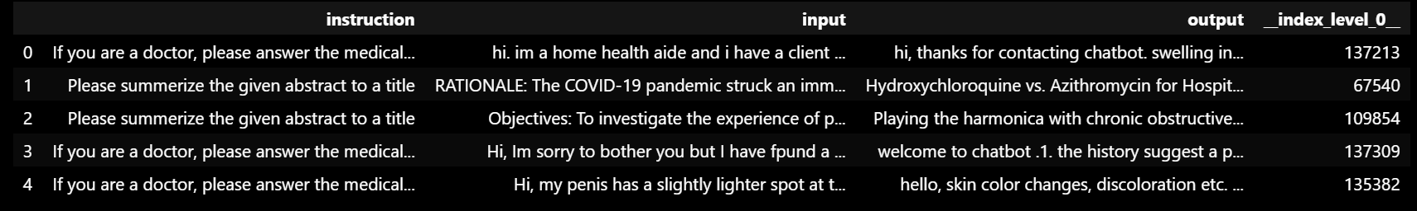

# making environment for LLM from hugging face

$env:FORCE_CMAKE=1

$env:CMAKE_ARGS="-DLLAMA_CUBLAS=on"

pip install llama-cpp-python --force-reinstall --upgrade --no-cache-dir

pip install llama-index

pip install transformers

pip install torch

pip install langchain-community

pip install langchain

This will allow you to use Mistral 7B and the Embedding models.

*Begin by organizing your dataset into a suitable format for Qdrant*

which involves embedding your text data into high-dimensional vectors. These vectors are then indexed in Qdrant, enabling efficient retrieval based on similarity.

For this we will be using <https://huggingface.co/sentence-transformers/paraphrase-multilingual-MiniLM-L12-v2> .

from transformers import AutoTokenizer, AutoModel

from pathlib import Path

def download_model_and_tokenizer(model_name, save_path):

    """

    Download and save both the model and the tokenizer to the specified directory.

    Parameters:

        model_name (str): Name of the model to download.

        save_path (str or Path): Path to the directory where the model and tokenizer will be saved.

    """

    # Create the save path if it doesn't exist

    save_path = Path(save_path)

    save_path.mkdir(parents=True, exist_ok=True)

    # Initialize tokenizer and model

    tokenizer = AutoTokenizer.from_pretrained(model_name)

    model = AutoModel.from_pretrained(model_name)

    # Save tokenizer

    tokenizer.save_pretrained(save_path)

    # Save model

    model.save_pretrained(save_path)

# Example usage

model_name = 'sentence-transformers/all-MiniLM-L12-v2'  # Model name to download

save_path = Path("MiniLM-L12-v2/")  # Path where model and tokenizer will be saved

download_model_and_tokenizer(model_name, save_path)

and then load the saved embedding model from the local

from transformers import AutoTokenizer, AutoModel

def load_model_and_tokenizer(model_path):

    """

    Load the model and tokenizer from the specified directory.

    Parameters:

        model_path (str or Path): Path to the directory containing the saved model and tokenizer.

    Returns:

        tokenizer (transformers.PreTrainedTokenizer): Loaded tokenizer.

        model (transformers.PreTrainedModel): Loaded model.

    """

    model_path = Path(model_path)

    tokenizer = AutoTokenizer.from_pretrained(model_path)

    model = AutoModel.from_pretrained(model_path)

    return tokenizer, model

# Load the model and tokenizer

model_path = Path("MiniLM-L12-v2/")

tokenizer, model = load_model_and_tokenizer(model_path)

Initializing embedding functions

import torch

#Mean Pooling - Take attention mask into account for correct averaging

def mean_pooling(model_output, attention_mask):

    token_embeddings = model_output[0] #First element of model_output contains all token embeddings

    input_mask_expanded = attention_mask.unsqueeze(-1).expand(token_embeddings.size()).float()

    return torch.sum(token_embeddings * input_mask_expanded, 1) / torch.clamp(input_mask_expanded.sum(1), min=1e-9)

def generate_embedding(text):

    # Tokenize input text

    encoded_input = tokenizer(text, padding=True, truncation=True, return_tensors='pt')

    # Compute token embeddings with model

    with torch.no_grad():

        model_output = model(**encoded_input)

    # Perform mean pooling

    sentence_embedding = mean_pooling(model_output, encoded_input['attention_mask'])

    # Convert to numpy for FAISS compatibility and ensure it's 2D

    return sentence_embedding.cpu().numpy().reshape(1, -1)

Dataset manipulation techniques

Right now, taking the instance of the dataset

# Create dfcopy with 100 rows

dfcopy = df.head(15).copy()

# Display the first few rows

dfcopy.head()

dfcopy = dfcopy.drop("__index_level_0__", axis=1)

dfcopy.head()

dfcopy['merged_data'] = dfcopy.apply(lambda row: row['input'] + ' ' + row['output'], axis=1)

dfcopy.head()

# Generate embeddings for the 'input' column

dfcopy['embeddings'] = dfcopy['output'].apply(lambda x: generate_embedding(x)[0].tolist())

dfcopy.head()

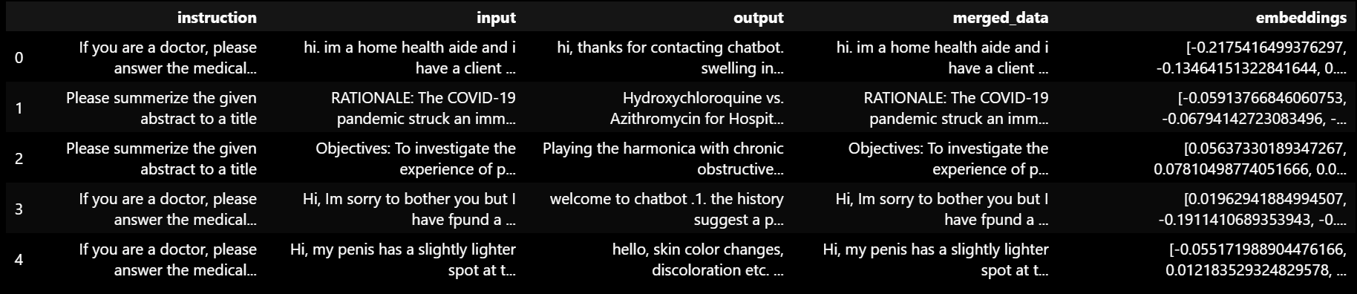

#### Qdrant Setup

First set up the virtual environment and then follow the installations:

# installing quadrant client

pip install qdrant-client

pip install dspy-ai[qdrant]

Now let's install and configure Qdrant on your server or local machine, creating a collection to store your vectors with appropriate configuration settings like distance metrics and vector dimensions.

Ensure the Docker hub is installed and

Initialize a Qdrant cluster

# Pull the latest Qdrant image from Dockerhub

docker pull qdrant/qdrant

# Run the Qdrant service on port 6333

docker run -p 6333:6333 -p 6334:6334 -v ${PWD}/qdrant_storage:/qdrant/storage:z qdrant/qdrant

# Set the HTTP port for Qdrant to 6333 (optional)

$env:QDRANT__SERVICE__HTTP_PORT = "6333"

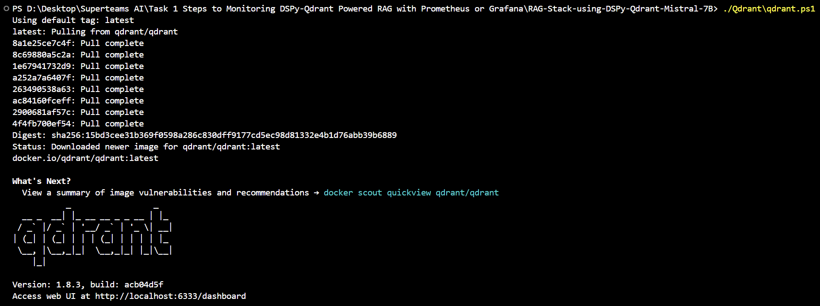

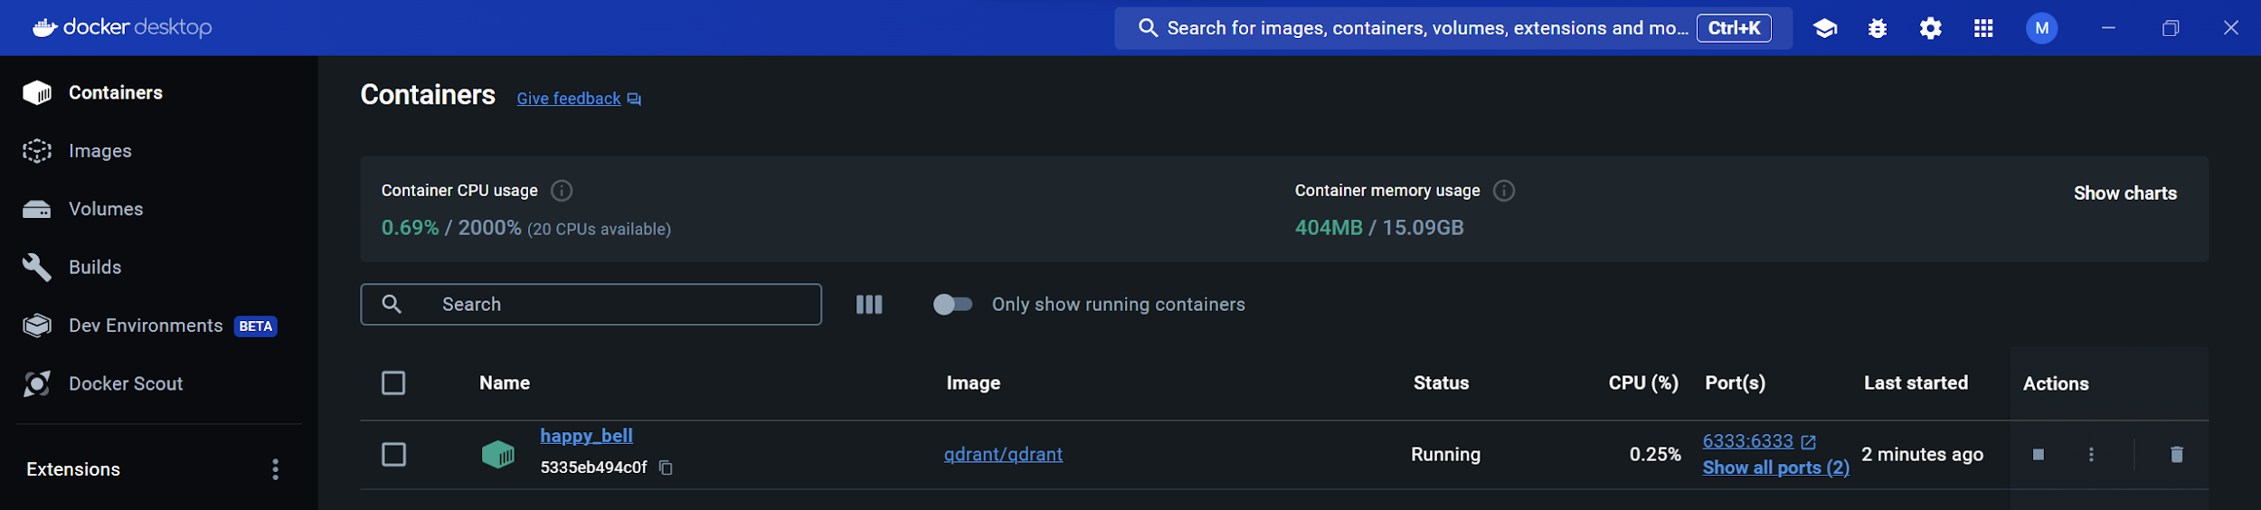

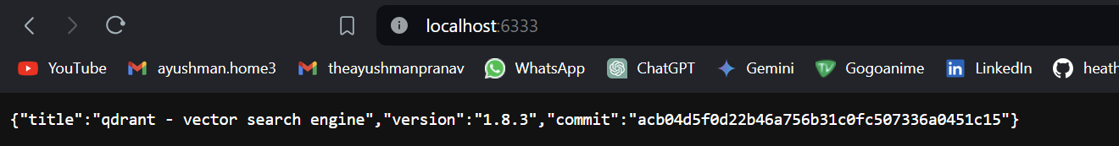

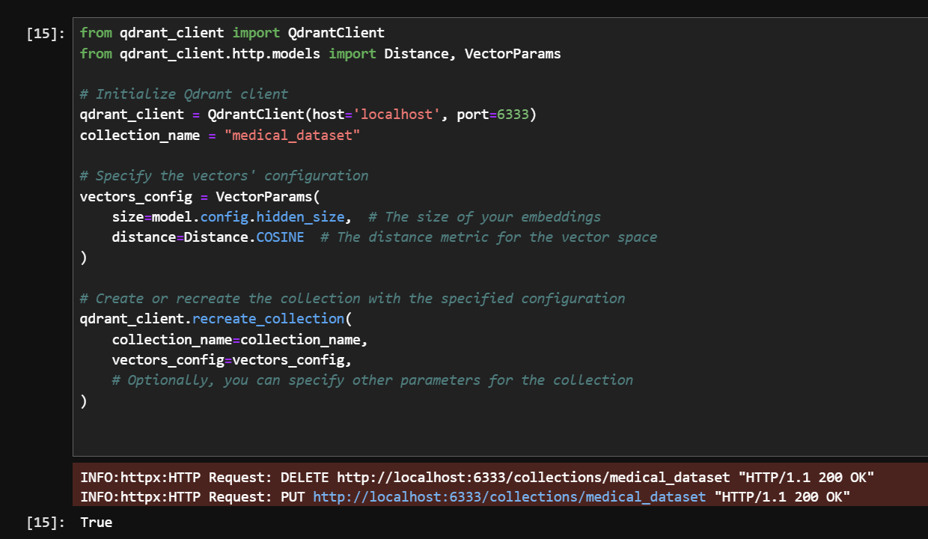

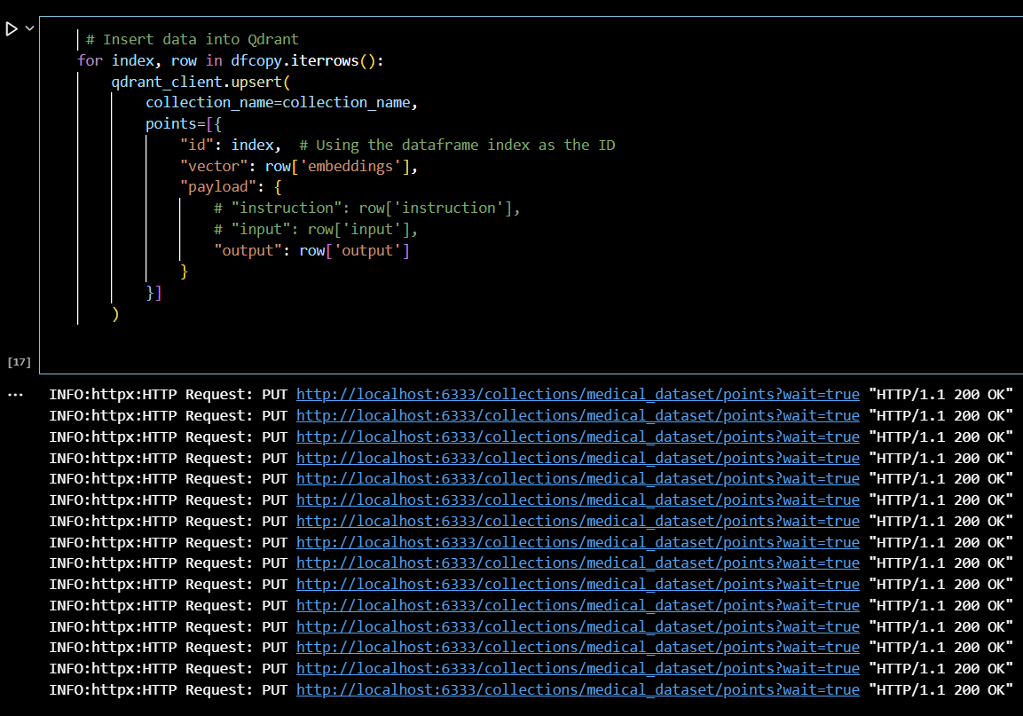

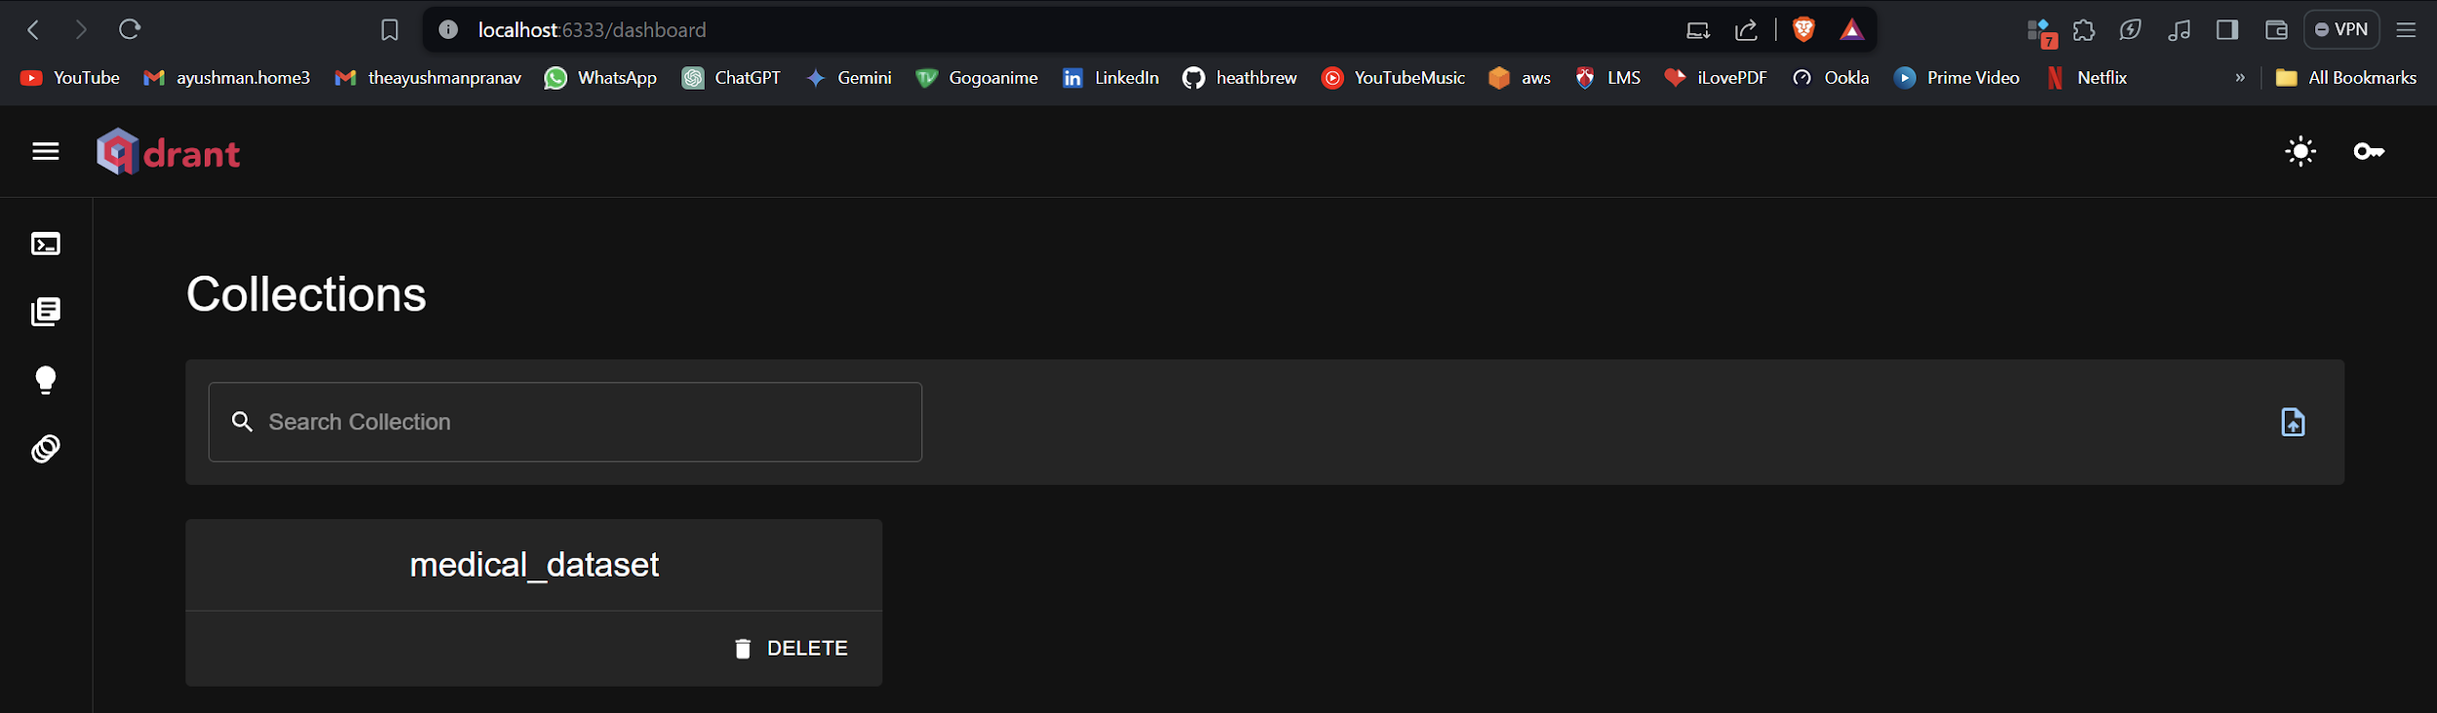

#### Model Integration

With the Qdrant server running, integrate Mistral 7B into your pipeline. Ensure that the model can access the retrieved data from Qdrant to utilize as context for generating responses.

This will initiate the Mistral LLM chain.

from langchain.callbacks.manager import CallbackManager

from langchain.callbacks.streaming_stdout import StreamingStdOutCallbackHandler

from langchain.chains import LLMChain

from langchain.prompts import PromptTemplate

from langchain_community.llms import LlamaCpp

model_path = r"Mistral7b_Model/mistral-7b-instruct-v0.1.Q5_K_M.gguf"

n_gpu_layers = -1  # Use GPU if possible, rest on CPU

n_batch = 512  # Adjust based on GPU VRAM

try:

    llm = LlamaCpp(

        model_path=model_path,  # Only use model_url, not model_path

        n_gpu_layers=n_gpu_layers,

        n_batch=n_batch,

        verbose=True  # Needed for callback manager

    )

    # Add your code using llm here

except Exception as e:

    print(f"Error creating LlamaCpp instance: {e}")

Let’s check for a sample prompt.

template = """Question: {question}

Answer: Let's work this out in a step by step way to be sure we have the right answer."""

prompt = PromptTemplate.from_template(template)

llm_chain = LLMChain(prompt=prompt, llm=llm)

question = "What is Azythromicin?"

llm_chain.run(question)

Response

**"\n\nStep 1: We know that azithromycin is an antibiotic, specifically it belongs to the class of drugs called macrolides. Macrolides are a broad spectrum of antibiotics that can target a wide range of bacteria.\n\nStep 2: Azithromycin works by interfering with the ability of certain bacteria to produce proteins they need to survive. This leads to the death of the bacteria.\n\nStep 3: Azithromycin has been used to treat various bacterial infections such as sinus and respiratory tract infections, skin infections, and urinary tract infections.\n\nStep 4: It can also be used to treat sexually transmitted diseases such as chlamydia and gonorrhea.\n\nStep 5: It is important to note that azithromycin can have side effects such as nausea, vomiting, diarrhea, and abdominal pain. It can also interact with other medications, so it's important to talk to your doctor before taking it."**

#### API Endpoints

Establish API endpoints that bridge your front end with the RAG stack. These endpoints should handle user queries, interact with Qdrant to fetch relevant data, and then pass this data along with the query to Mistral 7B for response generation.

Setting up the query engine:

from langchain.vectorstores import Qdrant

url = "http://localhost:6333"  # URL where the Qdrant service is running

collection_name =  "medical_dataset"  # Name of the collection in Qdrant

# Initialize the Qdrant client with the specified URL

client = QdrantClient(

    url=url,

    prefer_grpc=False  # Indicates whether to use gRPC for communication

)

logger.info(f"QdrantClient initialized: {client}")  # Prints the client information

logger.info(f"#################################")  # Prints a separator line

# Create a Qdrant object with the specified client, embeddings, and collection name

# Initialize the Qdrant vector store from langchain

db = Qdrant(

    client=client,

    embeddings=dfcopy['embeddings'].tolist(),  # Use the generated embeddings

    collection_name=collection_name

)

logger.info(f"Qdrant vector store initialized: {db}") # Prints the database object information

Setting up the similarity function and running a sample query.

def similarity_search_with_score(query, k=5):

    query_embedding = generate_embedding(query)[0].tolist()

    search_results = qdrant_client.search(

        collection_name=collection_name,

        query_vector=query_embedding,

        limit=k,

        with_payload=True,

        with_vectors=False

    )

    return search_results

query = "What is Azithromycin?"

search_results = similarity_search_with_score(query=query, k=5)

for result in search_results:

    doc_id = result.id

    score = result.score

    payload = result.payload  # The payload should contain your text or a reference to it.

    # Assuming the payload contains a field 'input' where the text is stored

    doc_content = payload.get('output', 'No content available')

    # Print the similarity score and document content

    logger.info({"score": score, "doc_id": doc_id, "content": doc_content})



## RAG Stack

Now both retrieval models are set up and our Mistral 7B is also ready to make sense of the retrievals.

Let’s merge them both.

from langchain import PromptTemplate, LLMChain

template = '''[INST]: You are a Medical expert analyst bot, below presents a context from which the a question will be asked, give your valuable insights as well.[\INST]\n

Context: {context}.\n

Question: {question}\n

Answer: '''

rag_prompt = PromptTemplate(template=template, input_variables=["context","question"])

callbacks = [StreamingStdOutCallbackHandler()]

llm_chain = LLMChain(prompt=rag_prompt, llm=llm, verbose=True)

We have to modify the similarity retrieval function from Qdrant we showed earlier because that retrieved the top docs without merging them.

We want a function which retrieves the top k docs and then merges them together after sorting them as per cosine similarity and passes them to LLM Mistral as Context.

def similarity_search_with_score(query, k=5):

    query_embedding = generate_embedding(query)[0].tolist()

    search_results = qdrant_client.search(

        collection_name=collection_name,

        query_vector=query_embedding,

        limit=k,

        with_payload=True,

        with_vectors=False

    )

    # Extract the document content from the payload and include it in the results

    results_with_content = []

    for result in search_results:

        doc_id = result.id

        score = result.score

        payload = result.payload  # The payload should contain your text or a reference to it.

        # Extract the document content from the payload

        doc_content = payload.get('output', 'No content available')

        results_with_content.append((score, doc_content))

    # Sort the results based on the similarity score in descending order

    sorted_results = sorted(results_with_content, key=lambda x: x[0], reverse=True)

    # Concatenate the content of the top k results

    concatenated_content = ' '.join([content for _, content in sorted_results[:k]])

    return concatenated_content

So, our final Calling looks like this:

query = "What is Azithromycin ?"

resp = llm_chain.invoke(

    input={"question":query,

           "context": similarity_search_with_score(query,k=5)

          }

)

print(resp['text'])

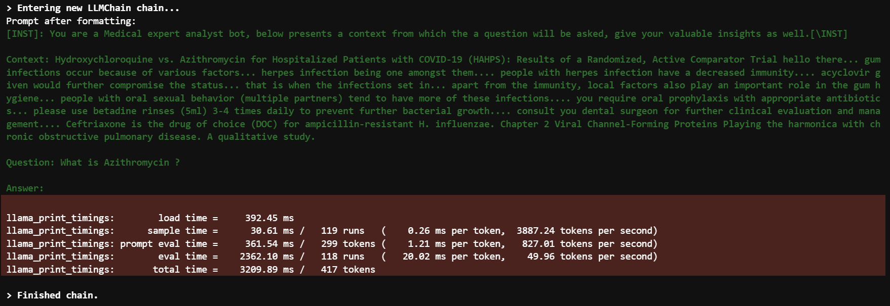

This is the Final Response.

**Azithromycin is an antibiotic used to treat various bacterial infections, including acute respiratory tract infections and skin infections. It works by targeting the bacterial cell wall and disrupting it, leading to their death. In addition to its antibiotic properties, azithromycin has also been used in the treatment of viral infections, such as HIV and COVID-19. However, its use in viral infections is not yet fully understood and requires further research to determine its efficacy and safety.**

As you can see, Mistral 7B responded with much more context using the retrieved data when asked the question again as compared to a normal call mentioned above.

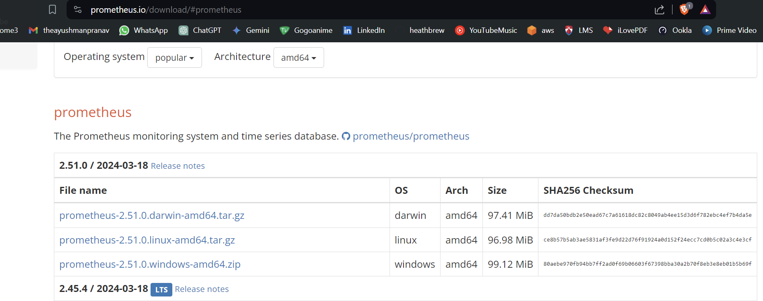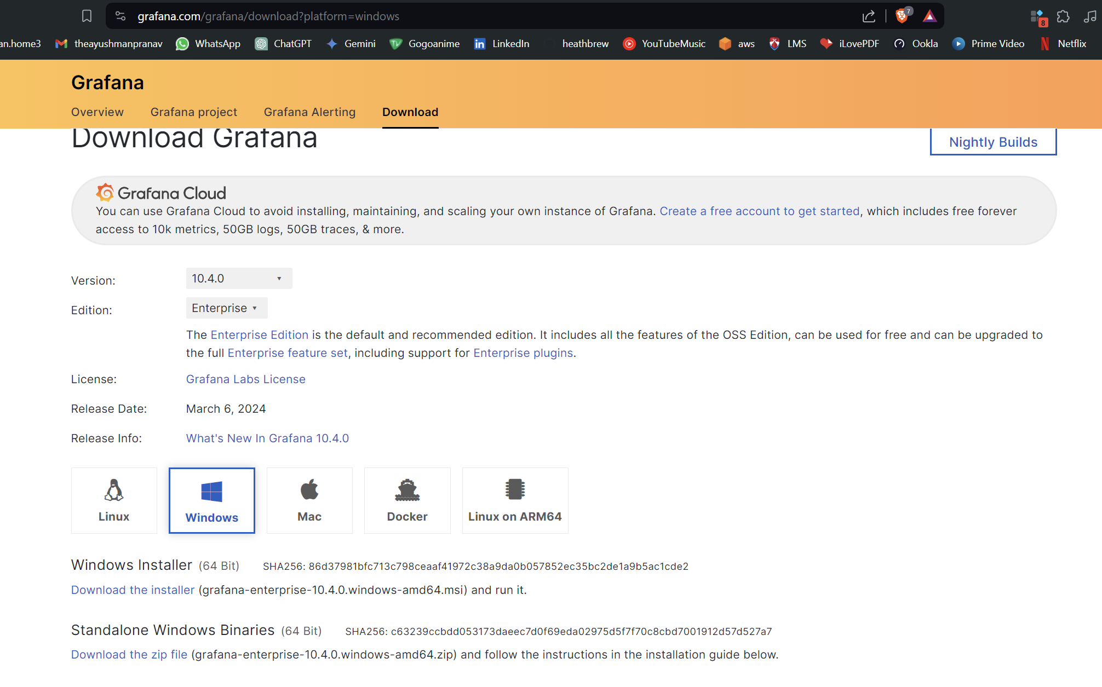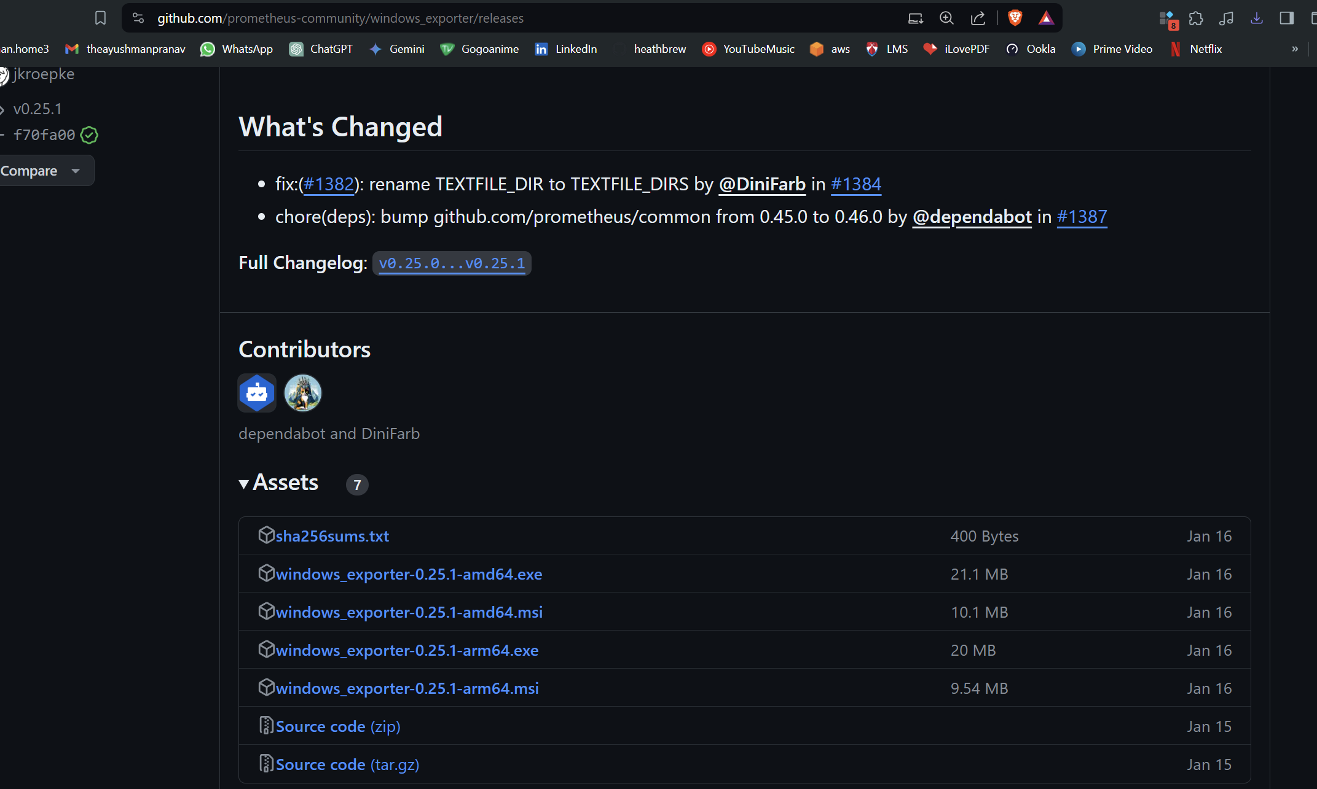

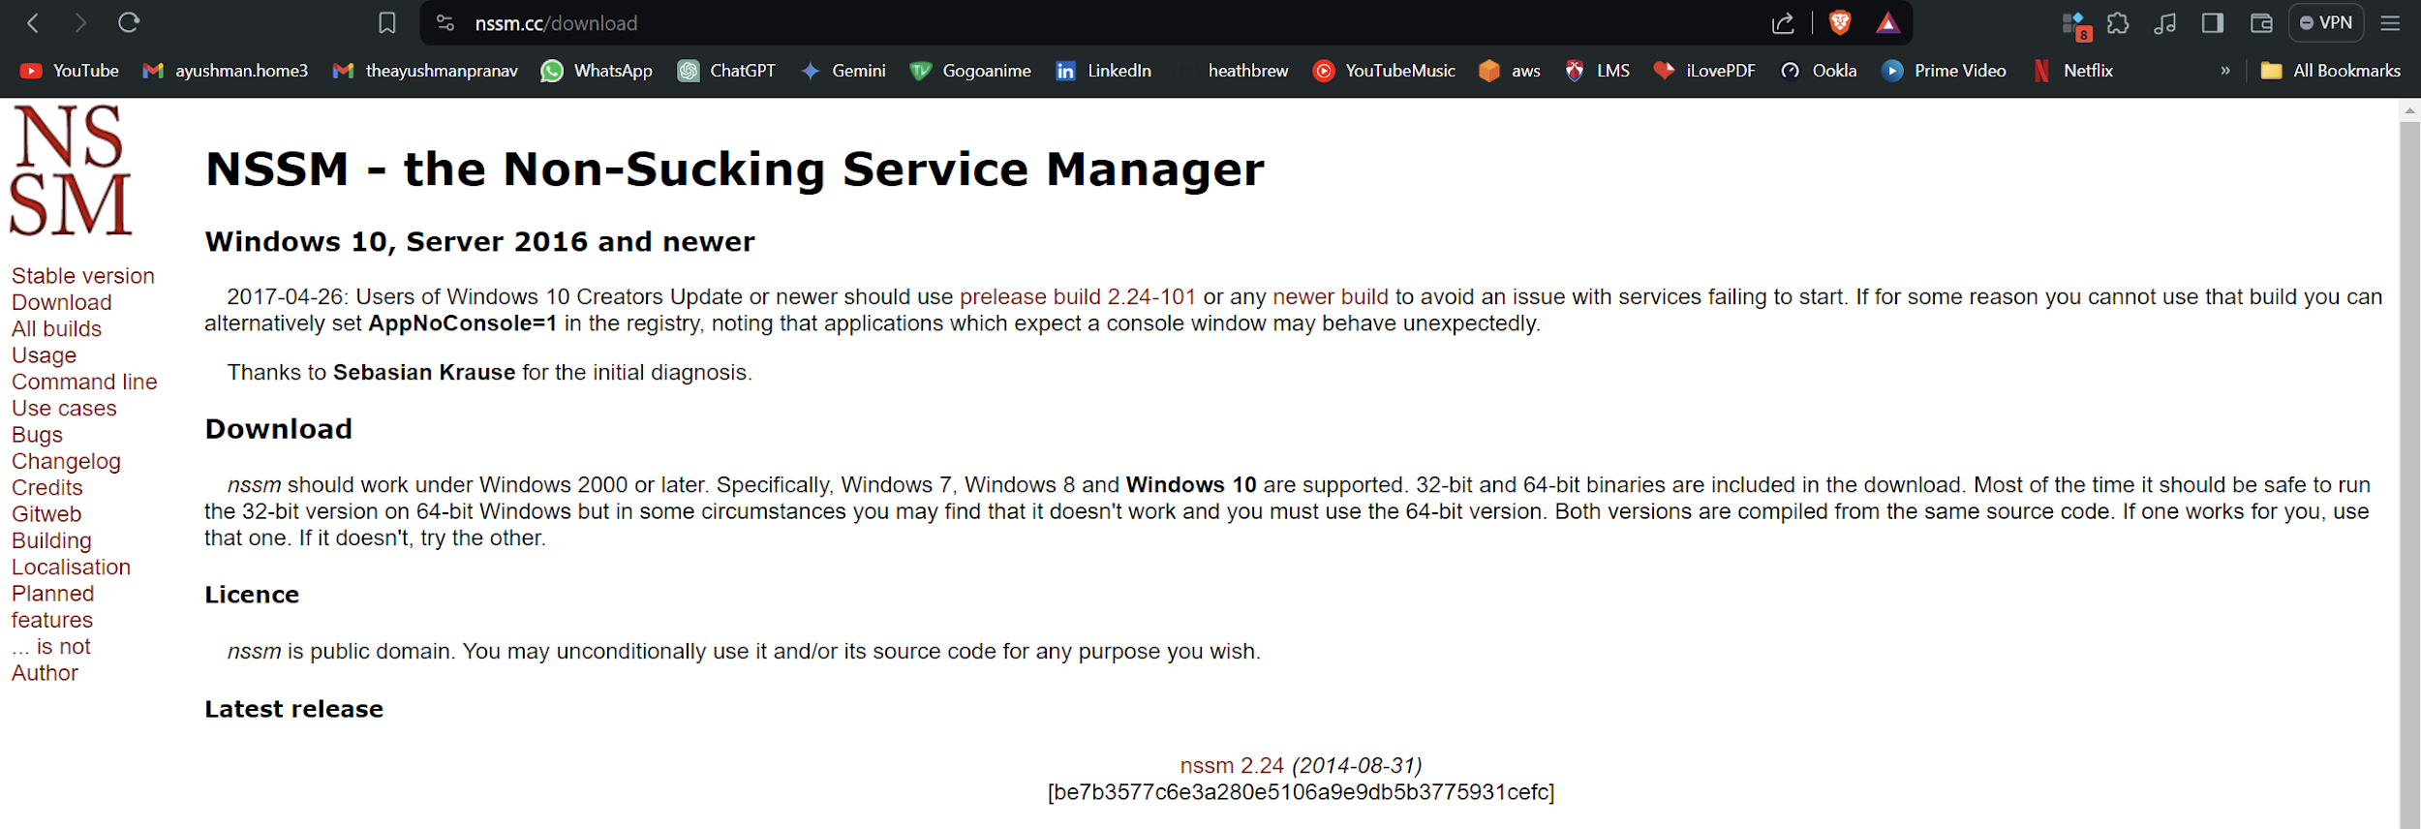

## Grafana installation

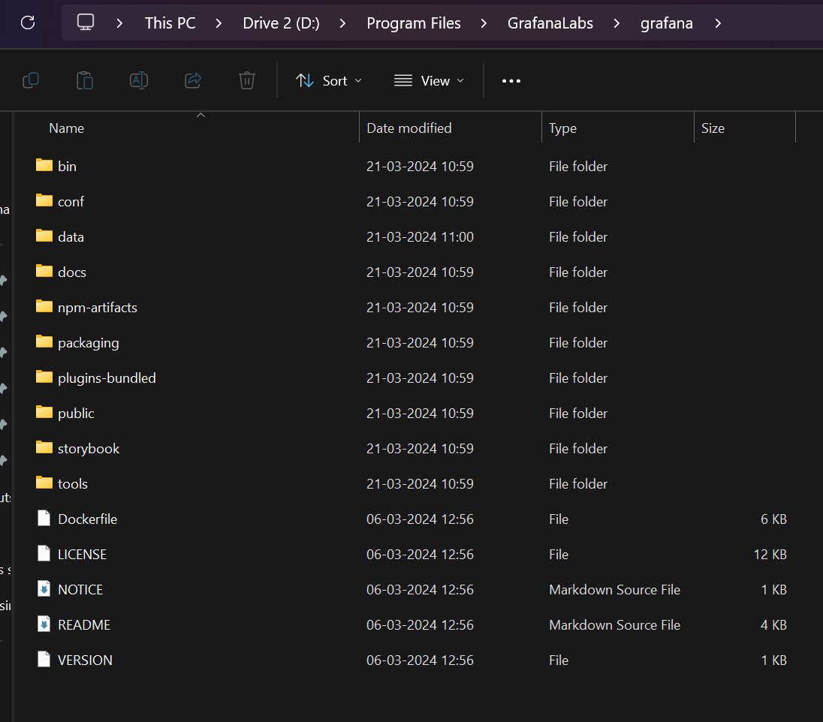

Go to config and then search for smtp

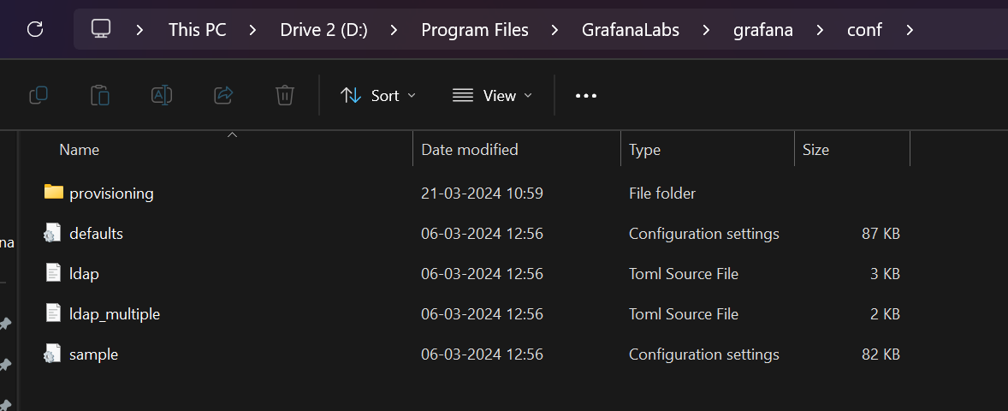  
Open defaults

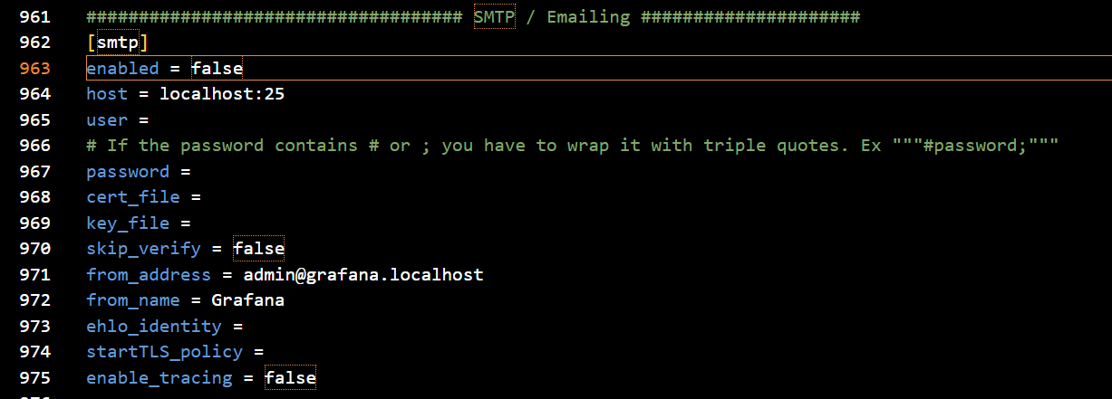

Switch enabled to true.

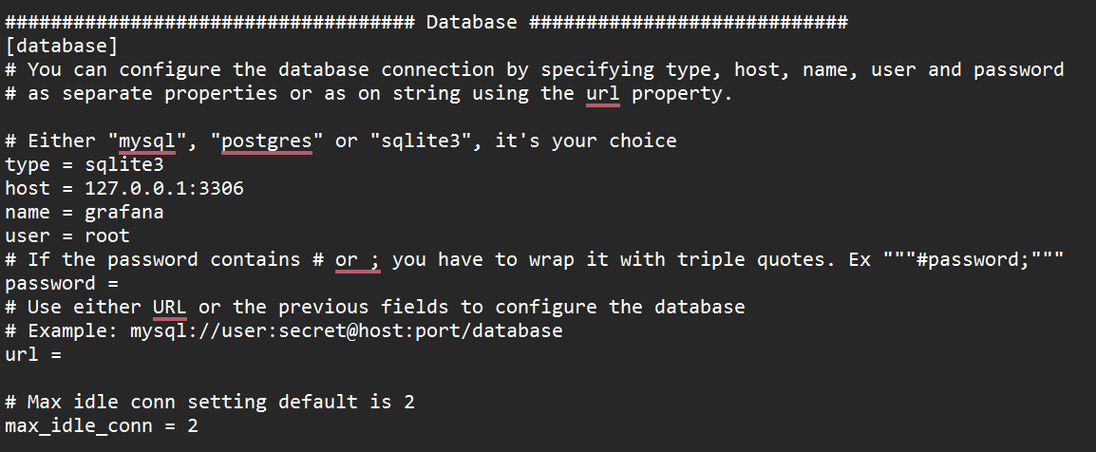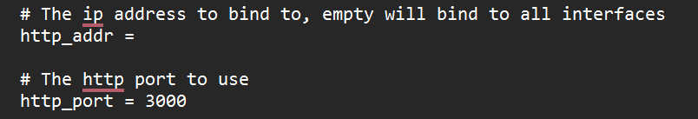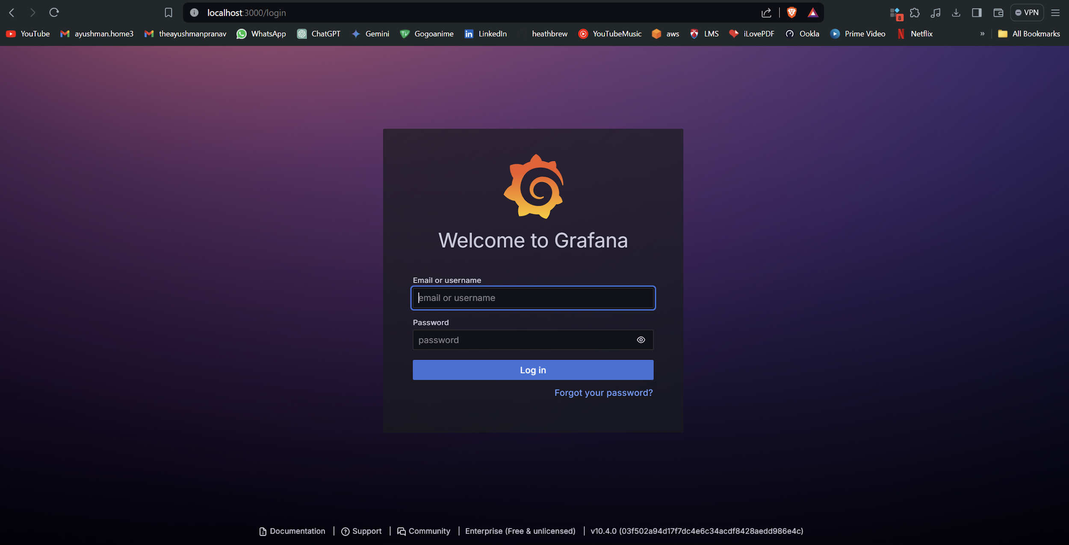 The default username and password is “admin”.

After logging in:

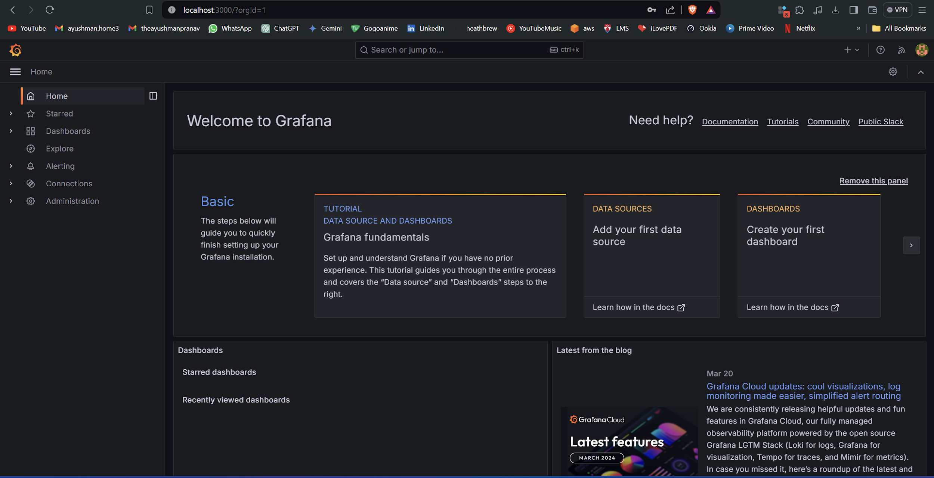

## *Prometheus Installation Using NSSM*

Go to the location of NSSM.

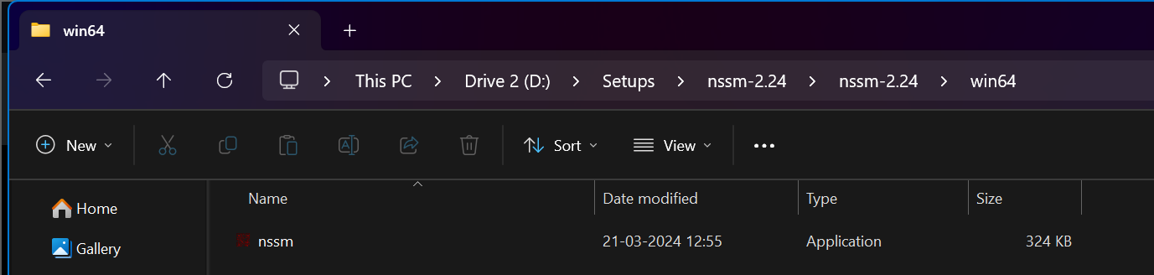

Copy the path of this folder

**D:\Setups\nssm-2.24\nssm-2.24\win64**

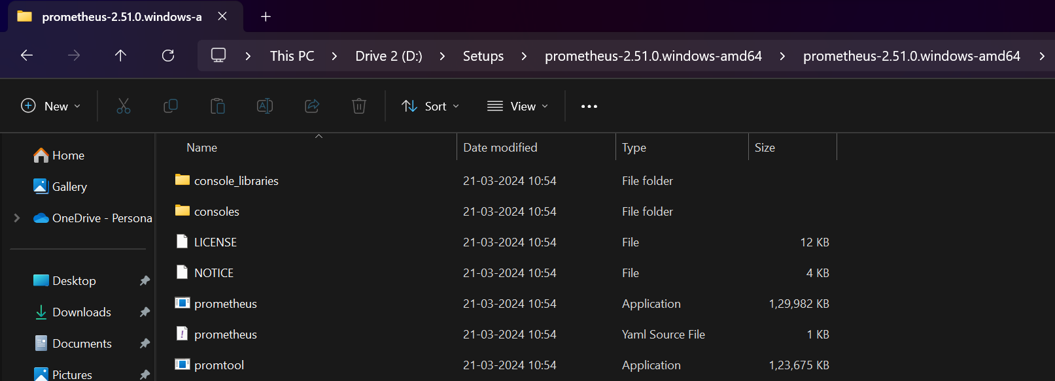

**Path of Prometheus**

**D:\Setups\prometheus-2.51.0.windows-amd64\prometheus-2.51.0.windows-amd64\prometheus.exe**

Open the command prompt in administrator mode

Cd into this path

Now we will prepare this command

nssm.exe install prometheus < path of prometheus.exe>

So now the command comes out to be

**.\nssm.exe install prometheus "D:\Setups\prometheus-2.51.0.windows-amd64\prometheus-2.51.0.windows-amd64\prometheus.exe"**

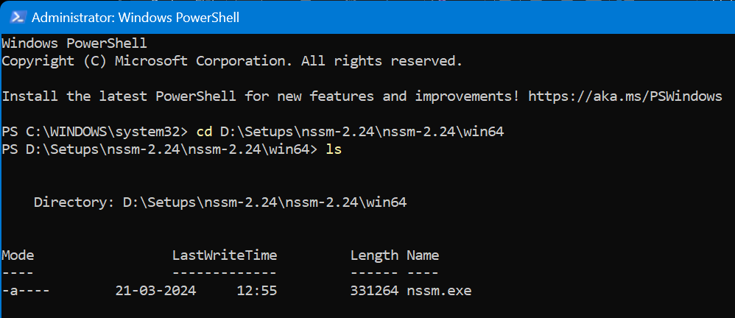



To permanently activate it, we need Windows exporter.

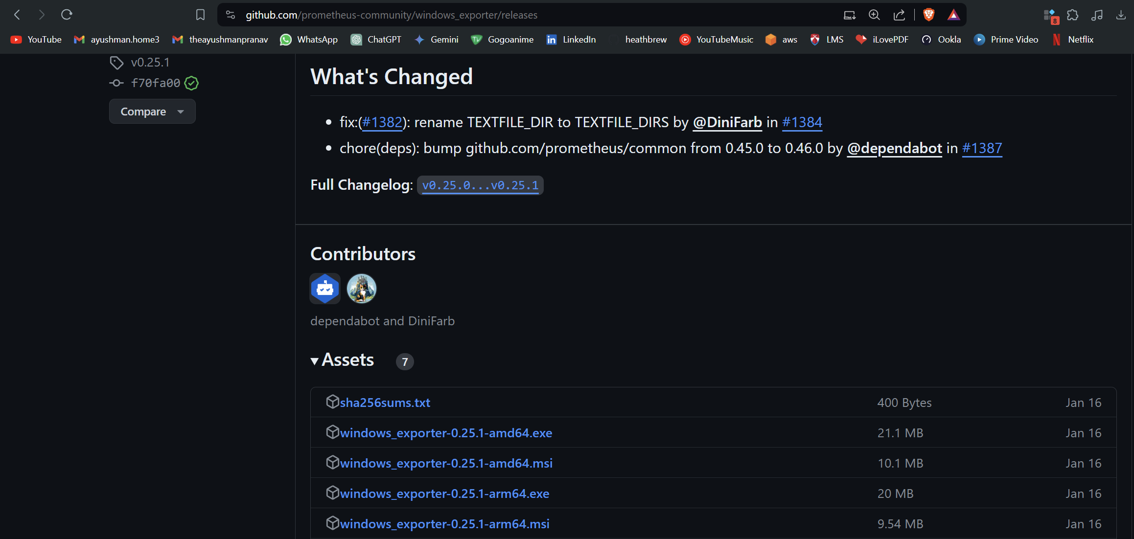

Download



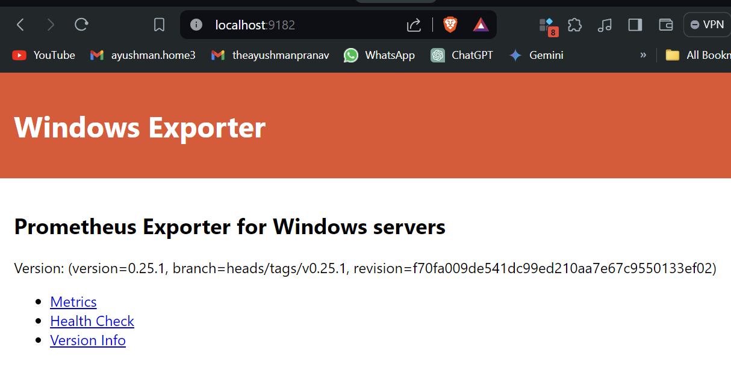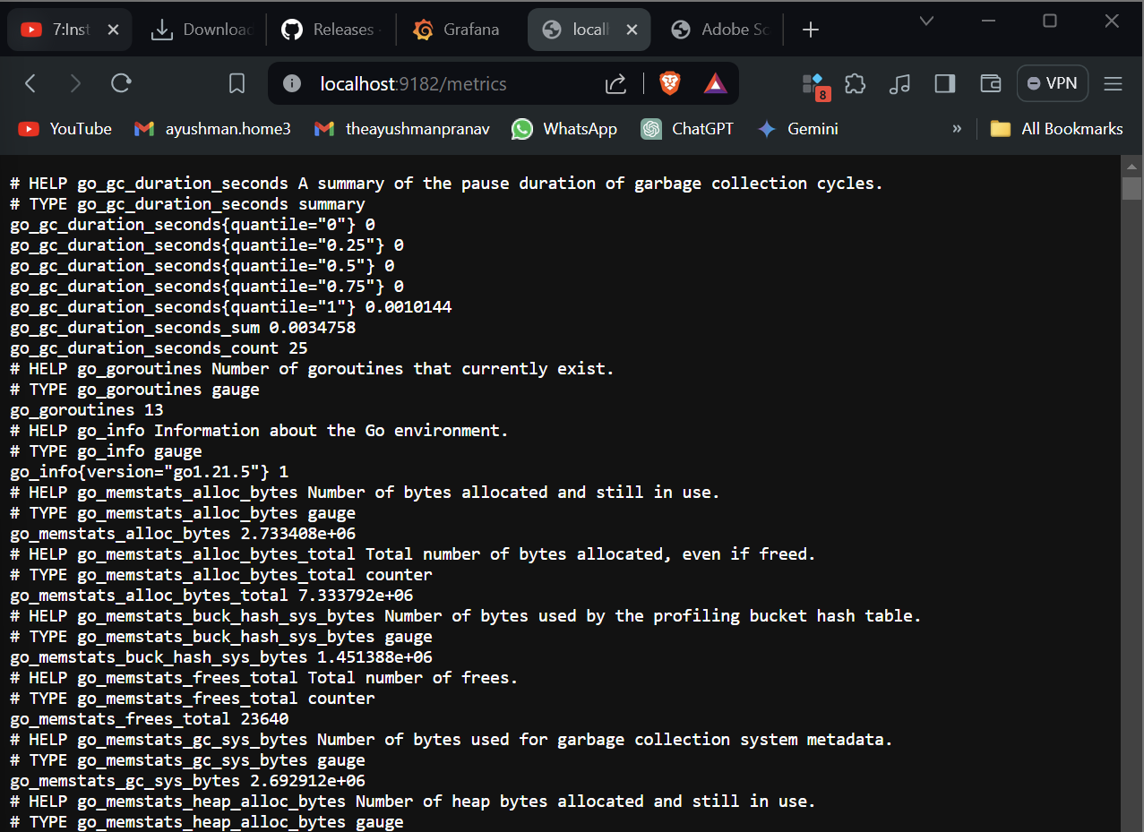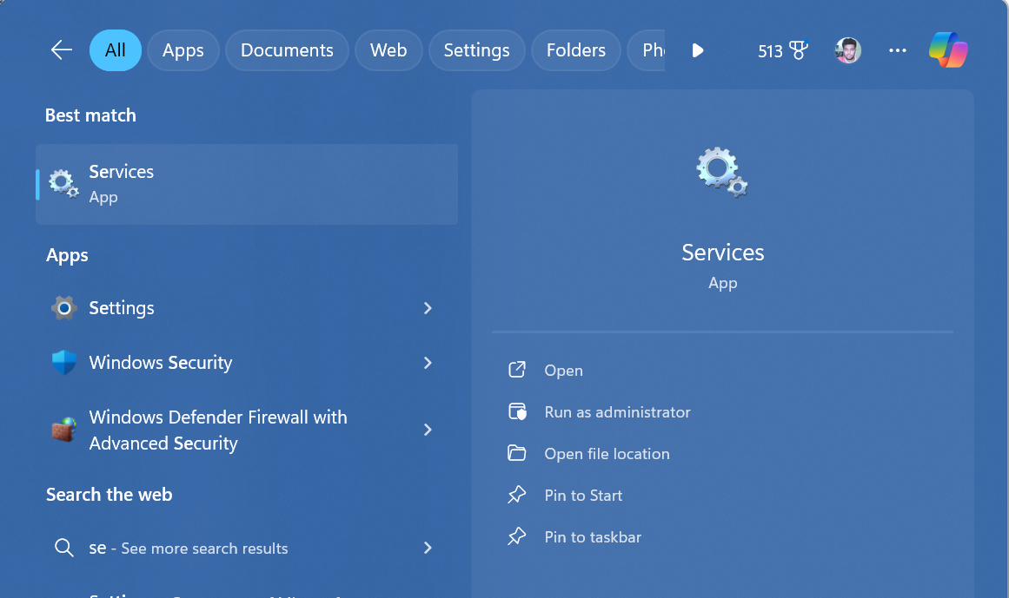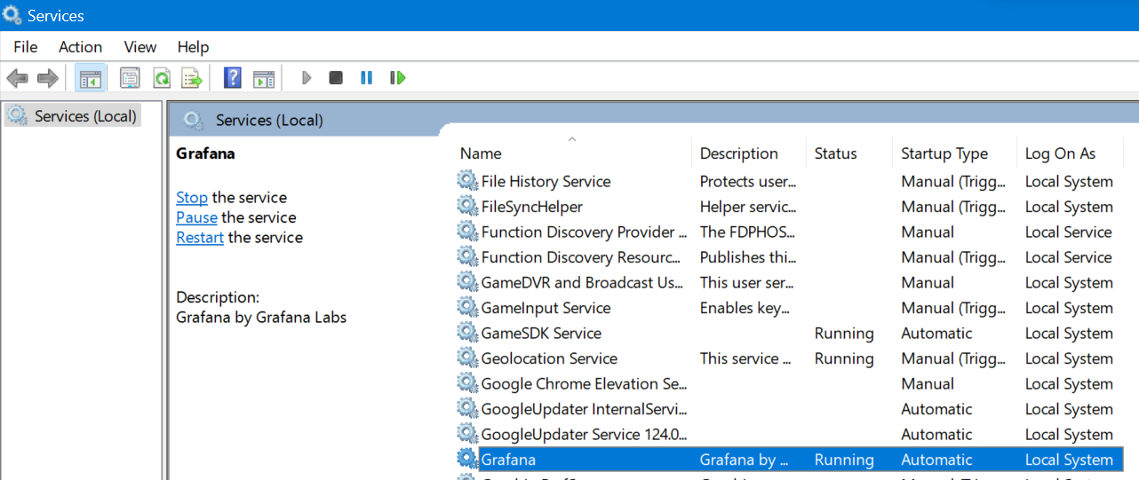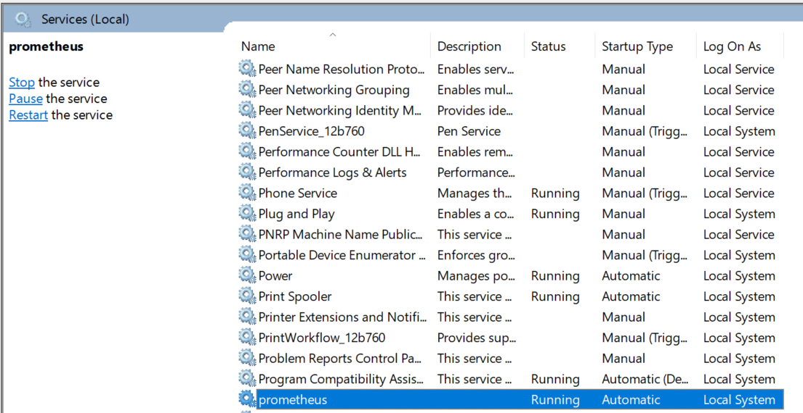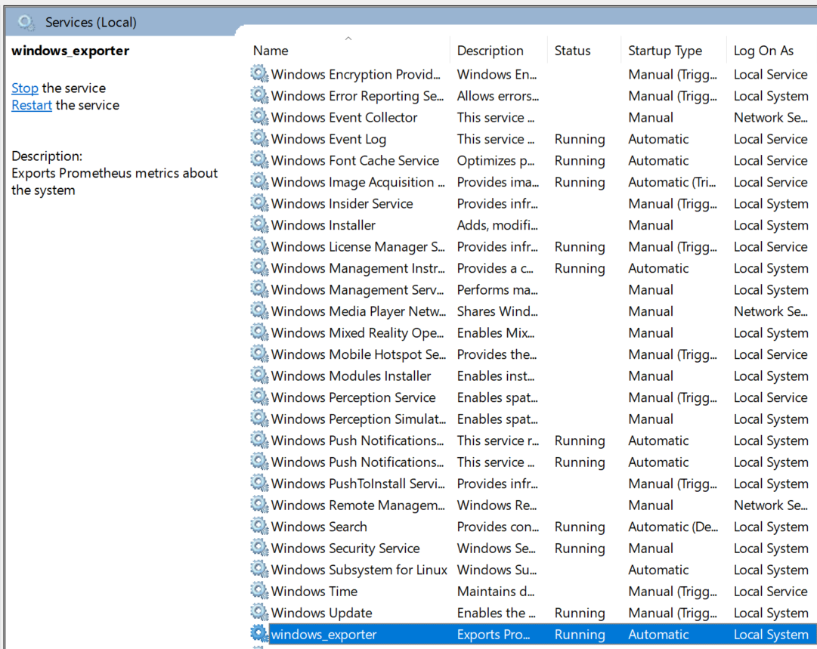

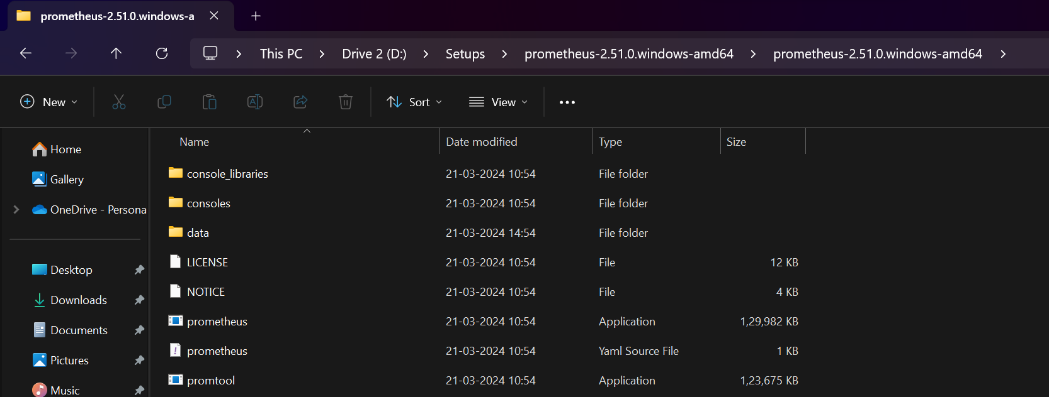

Go to Prometheus.yml.

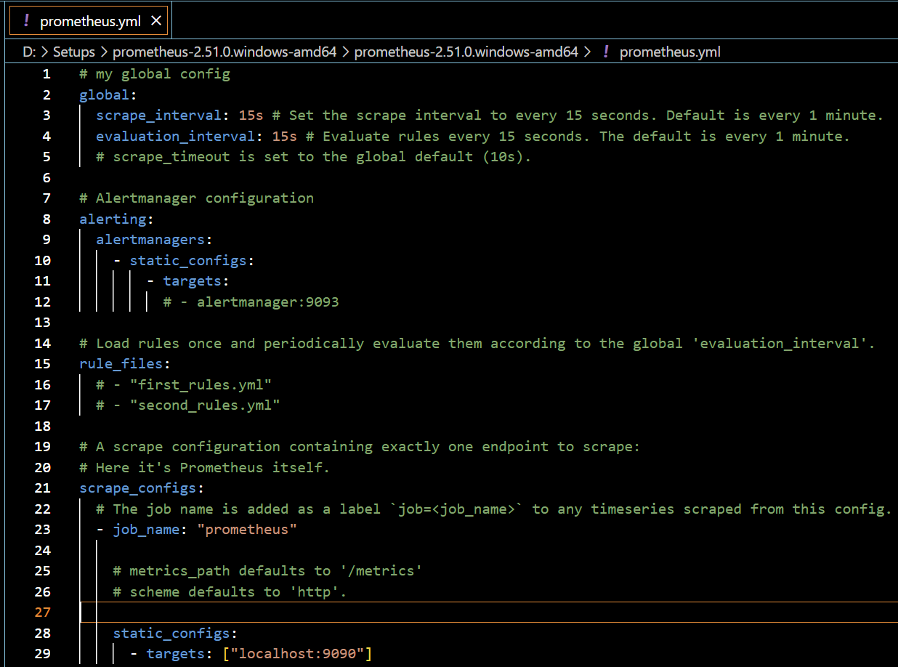Add Windows exporter.

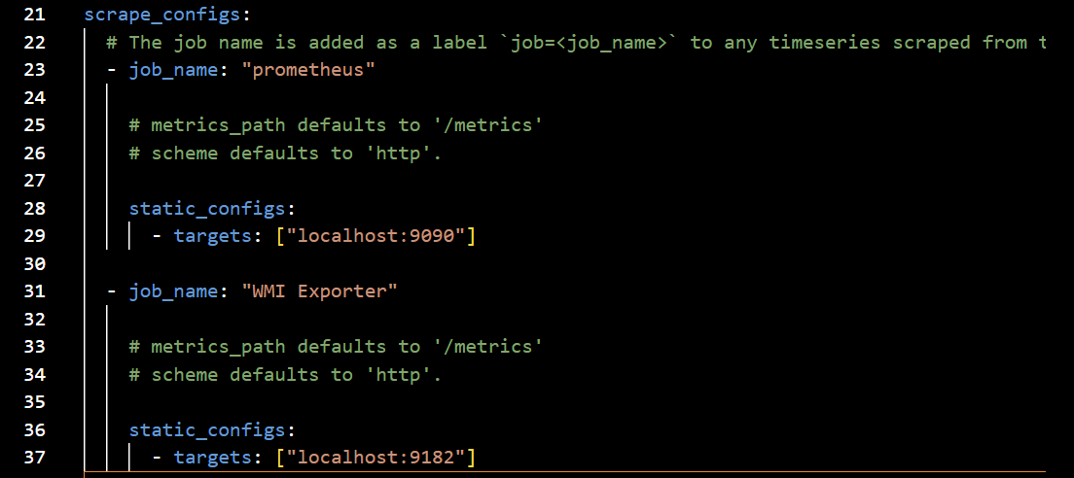



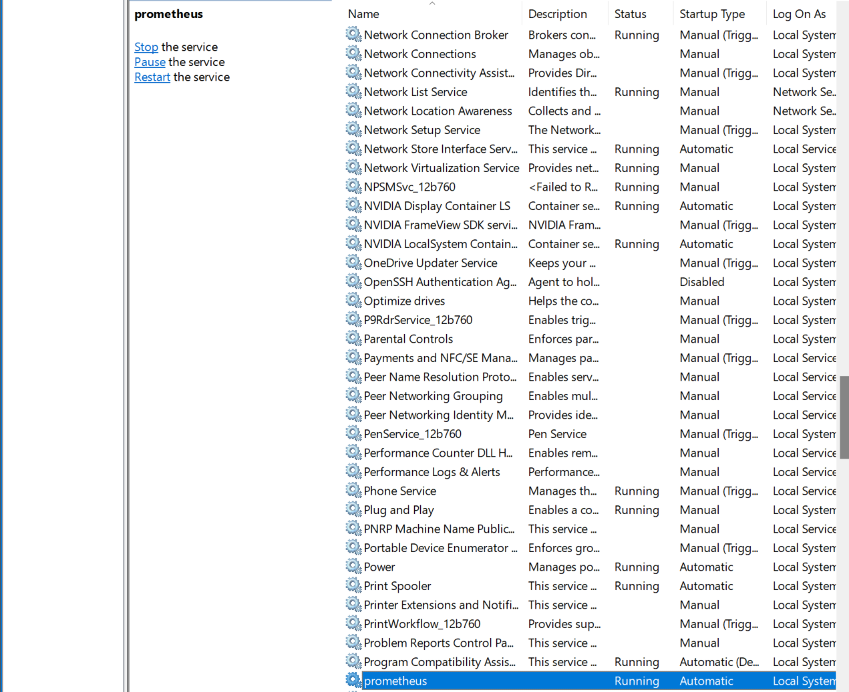

Restart the Prometheus service.

Check localhost: 9090

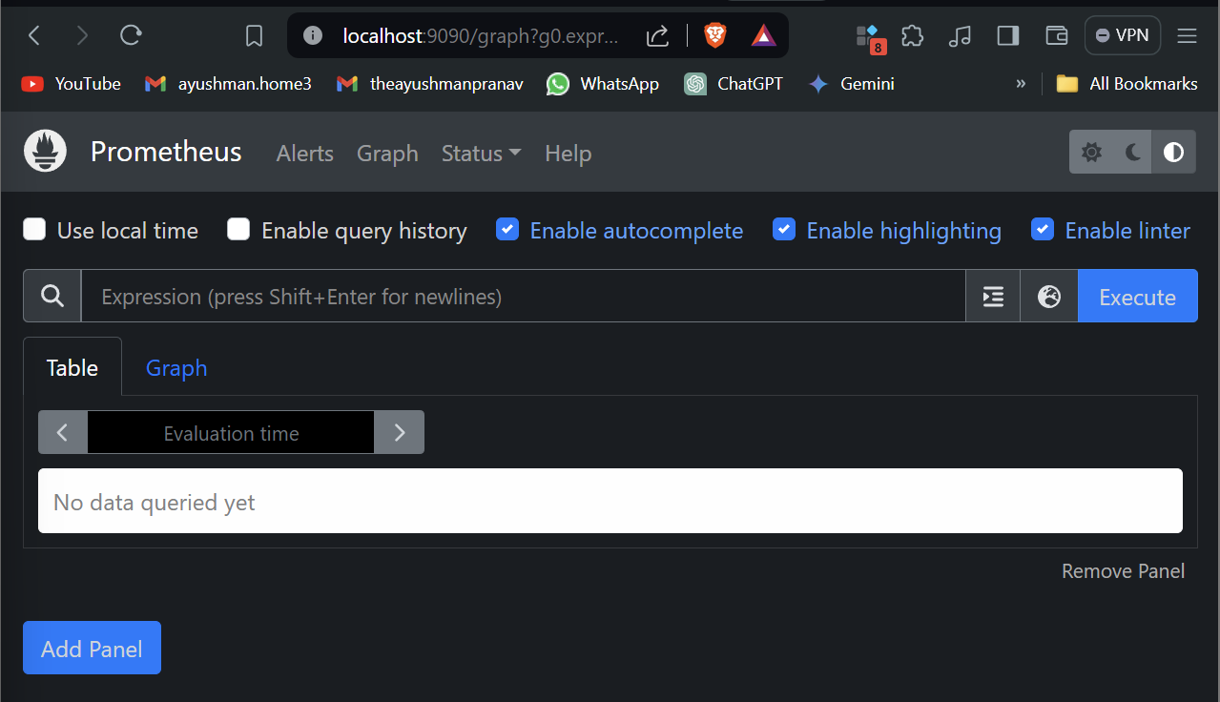

Welcome the Prometheus UI

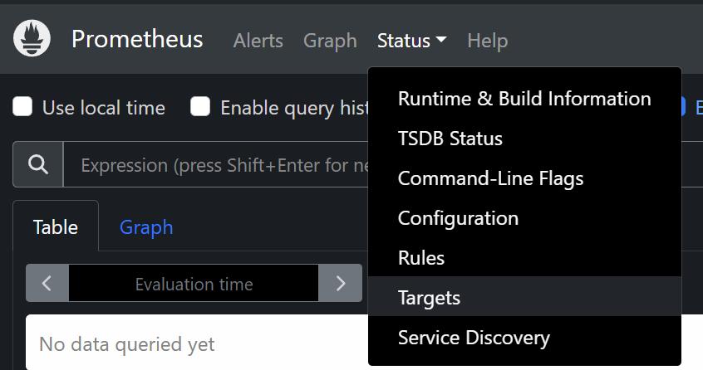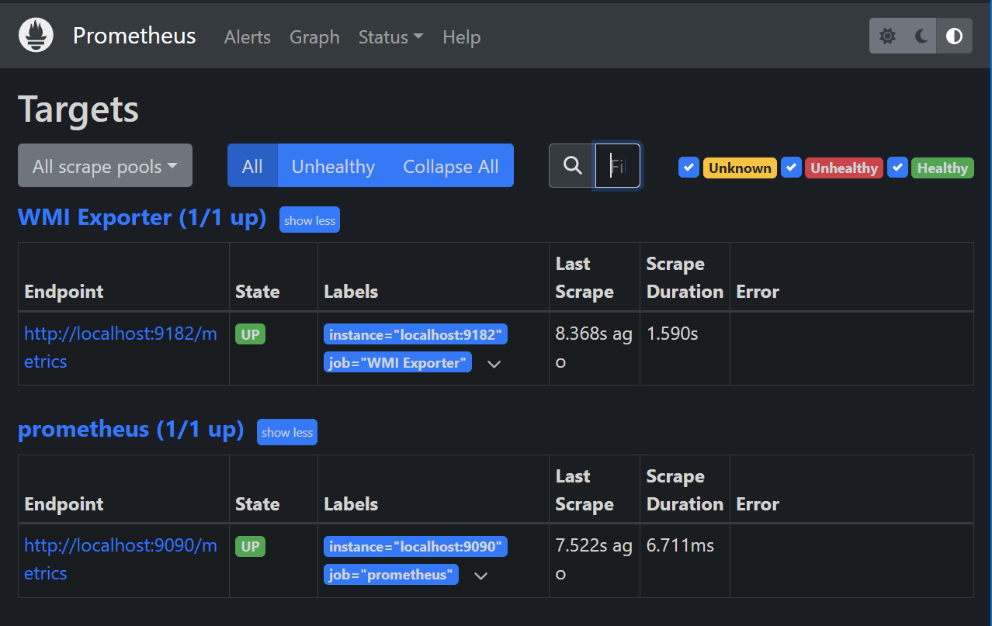

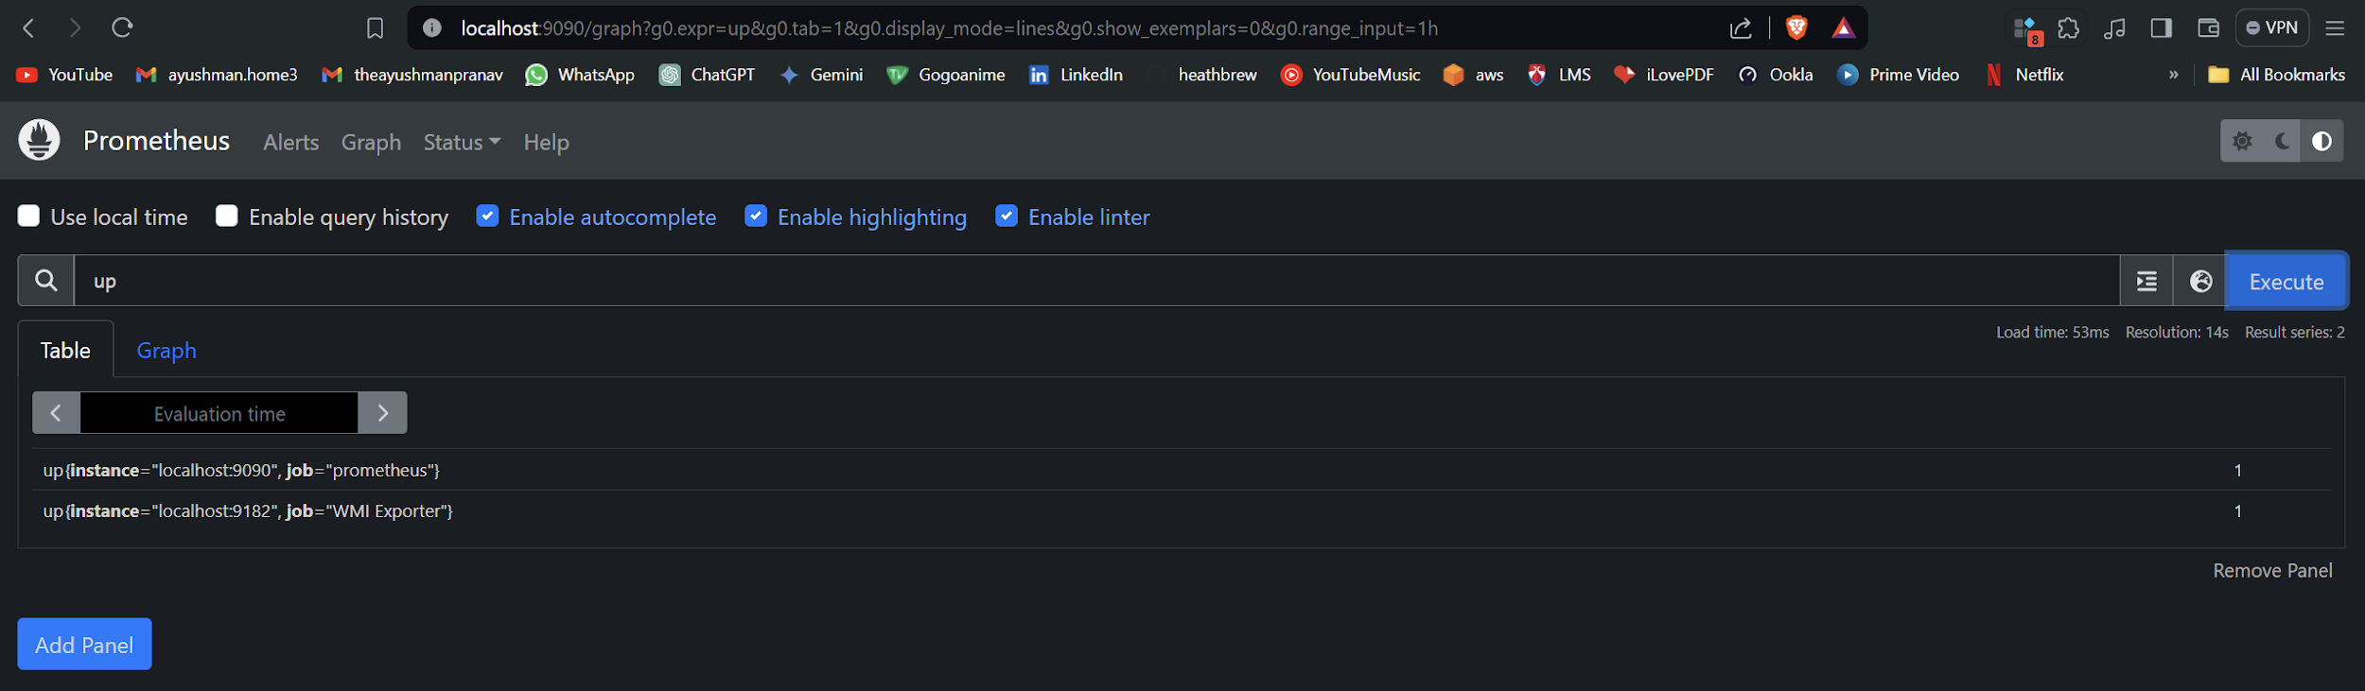

## *Configuring Grafana for the Metrics*

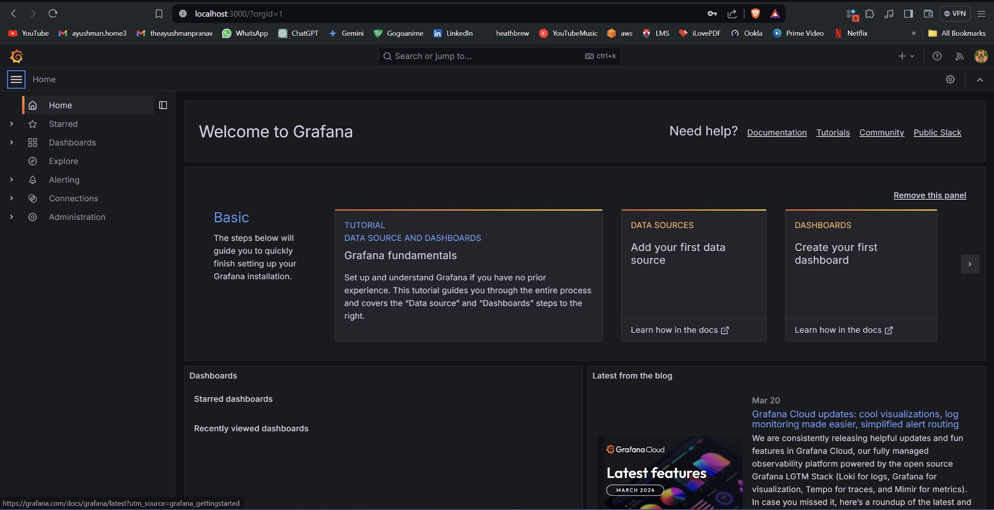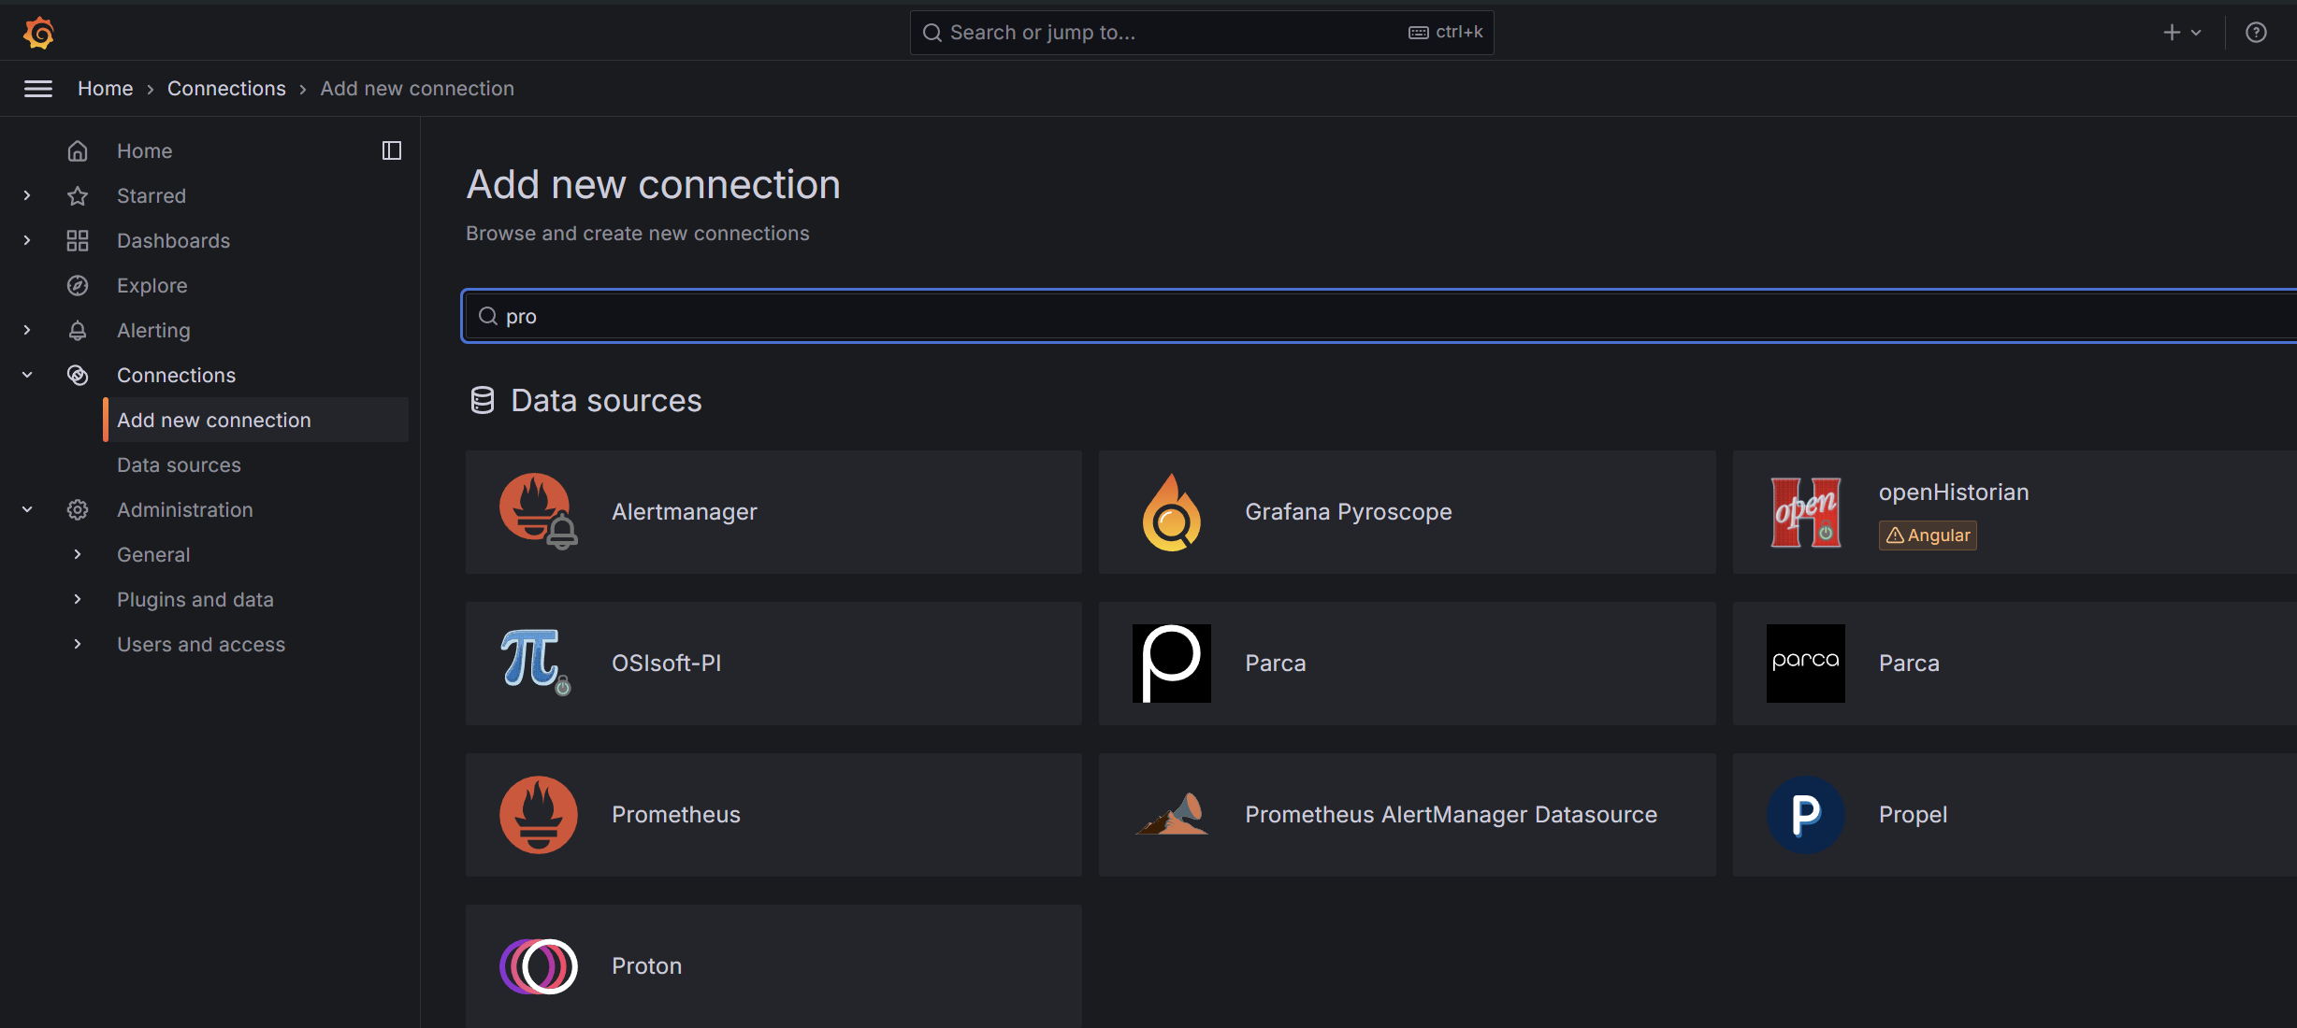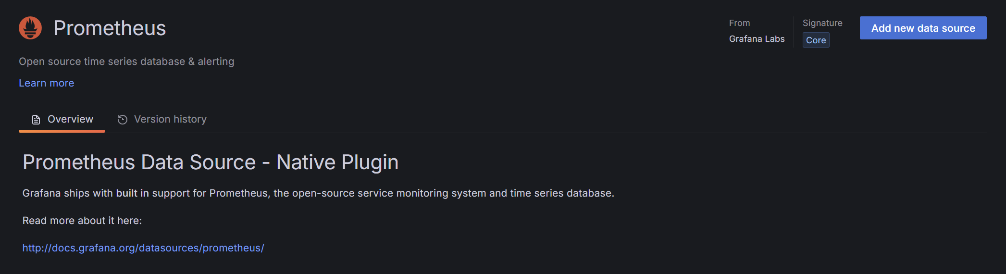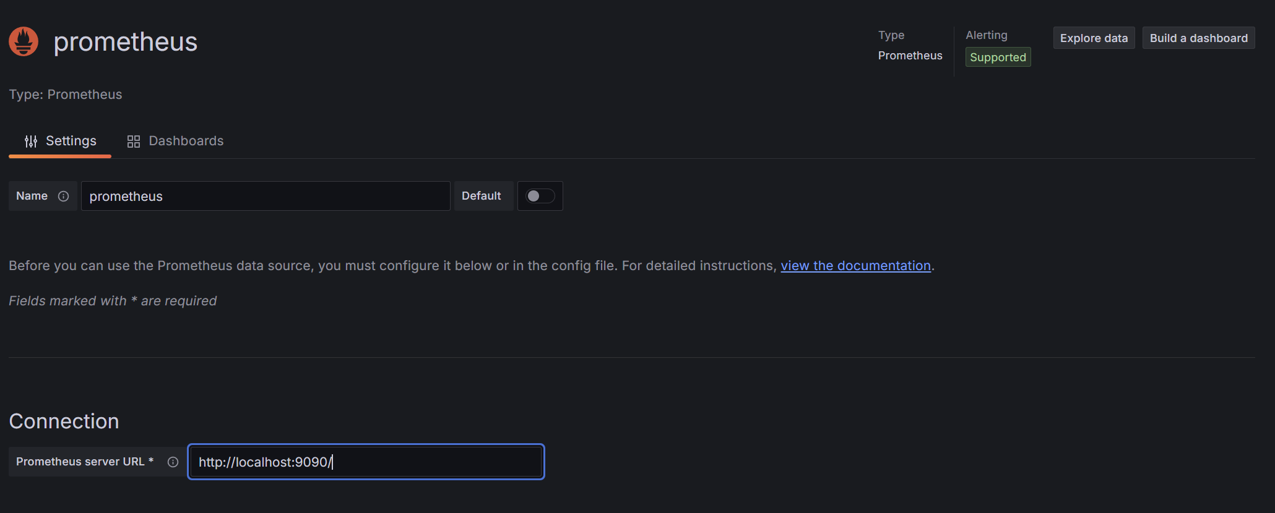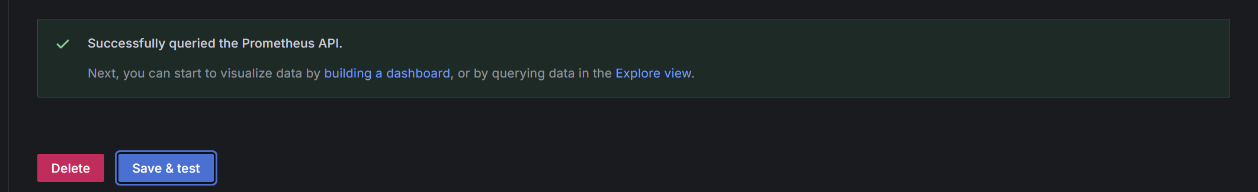

## *Making the Statistics Available*

Run the below command to restart Prometheus.



Restart the Prometheus service.



For Windows dashboard, the URL id is: 14510

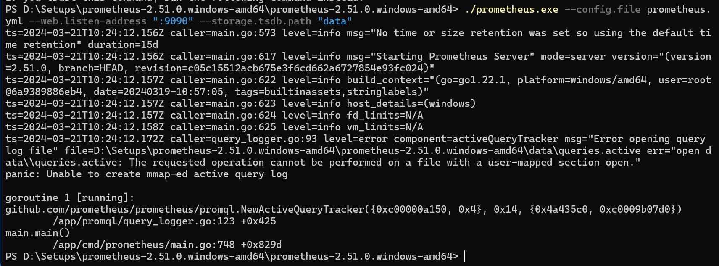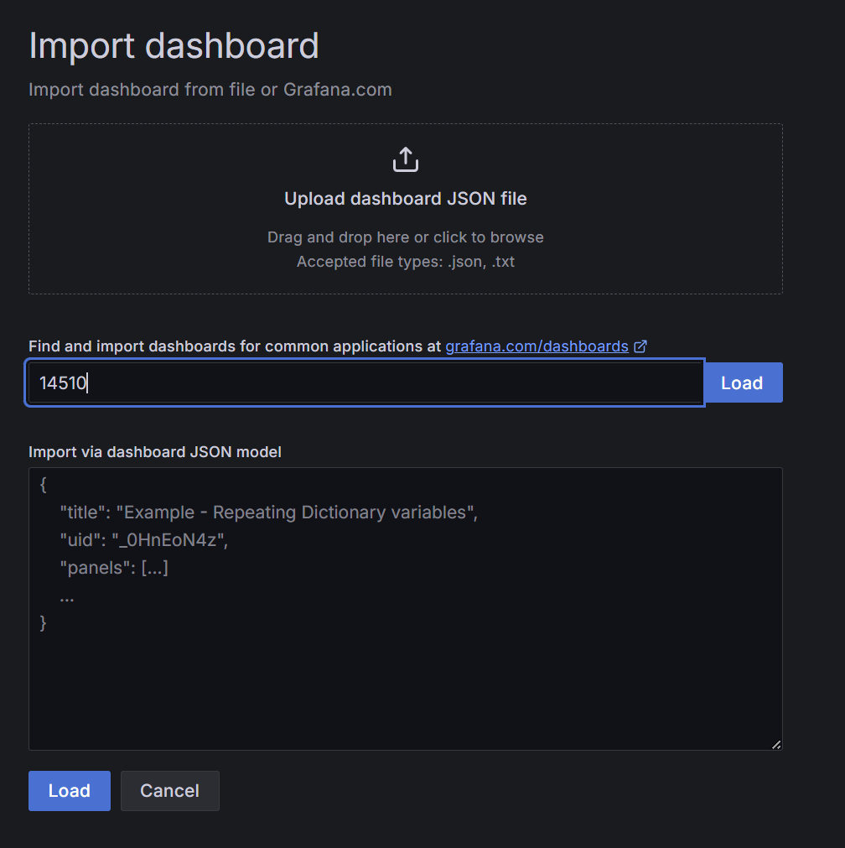

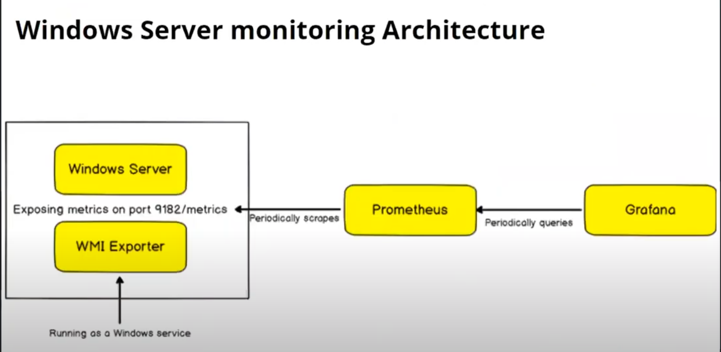

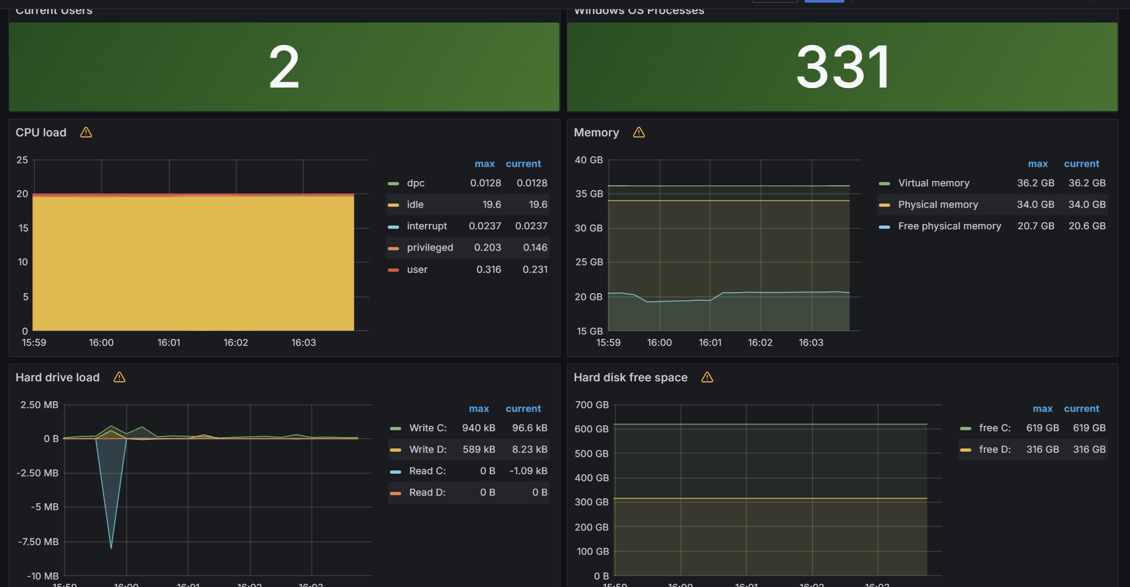

## *GPU Data Export to Grafana*

To set up the nvidia_gpu_exporter using Scoop on Windows, you can follow these steps based on the script provided on the web page you’re viewing:

**Install Scoop**: If Scoop is not already installed, you can install it by running the following command in PowerShell:

1. > Set-ExecutionPolicy -ExecutionPolicy RemoteSigned -Scope CurrentUser
2. > Invoke-RestMethod -Uri https://get.scoop.sh | Invoke-Expression

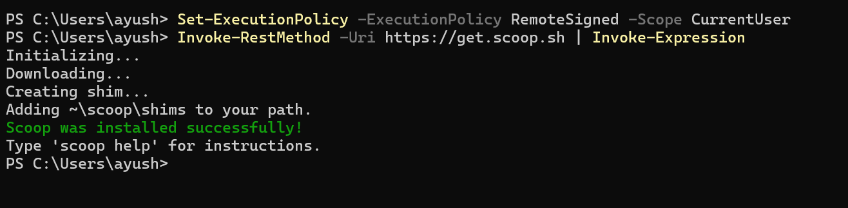

**Add the Extras Bucket**: Add the ‘extras’ bucket to Scoop, which contains additional apps and utilities:

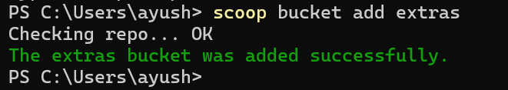

**Install NSSM**: Install the Non-Sucking Service Manager (NSSM) globally using Scoop:

scoop install nssm –global

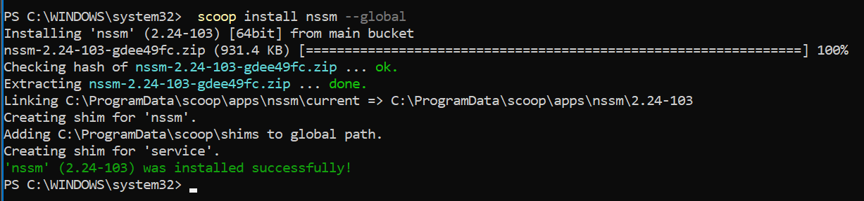

**Install and Set Up Nvidia GPU Exporter**: Add the nvidia_gpu_exporter bucket and install it globally:

scoop bucket add nvidia_gpu_exporter <https://github.com/utkuozdemir/scoop_nvidia_gpu_exporter.git>

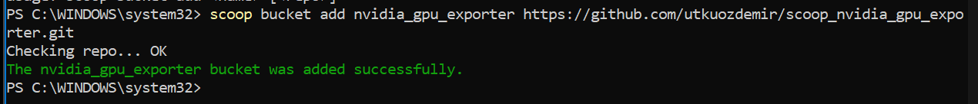

scoop install nvidia_gpu_exporter/nvidia_gpu_exporter –global

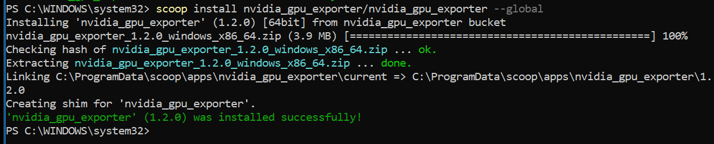

Then, use NSSM to install nvidia_gpu_exporter as a service and start it:

nssm install nvidia_gpu_exporter "C:\ProgramData\scoop\apps\nvidia_gpu_exporter\current\nvidia_gpu_exporter.exe"



Start-Service nvidia_gpu_exporter



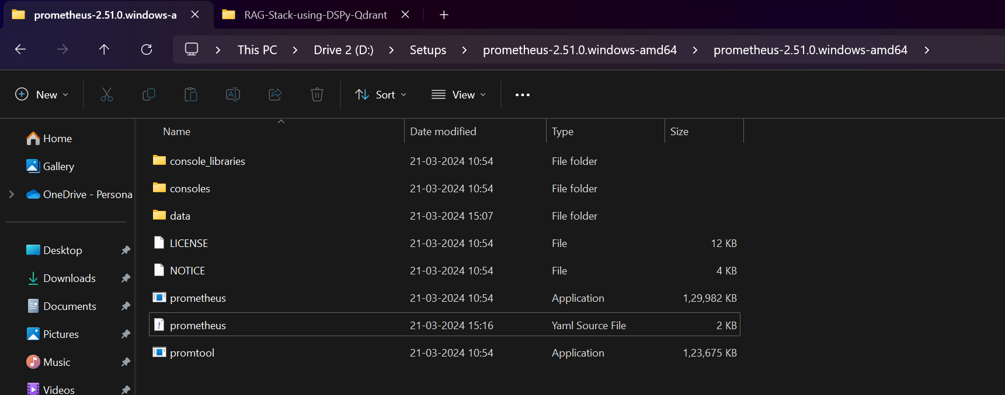

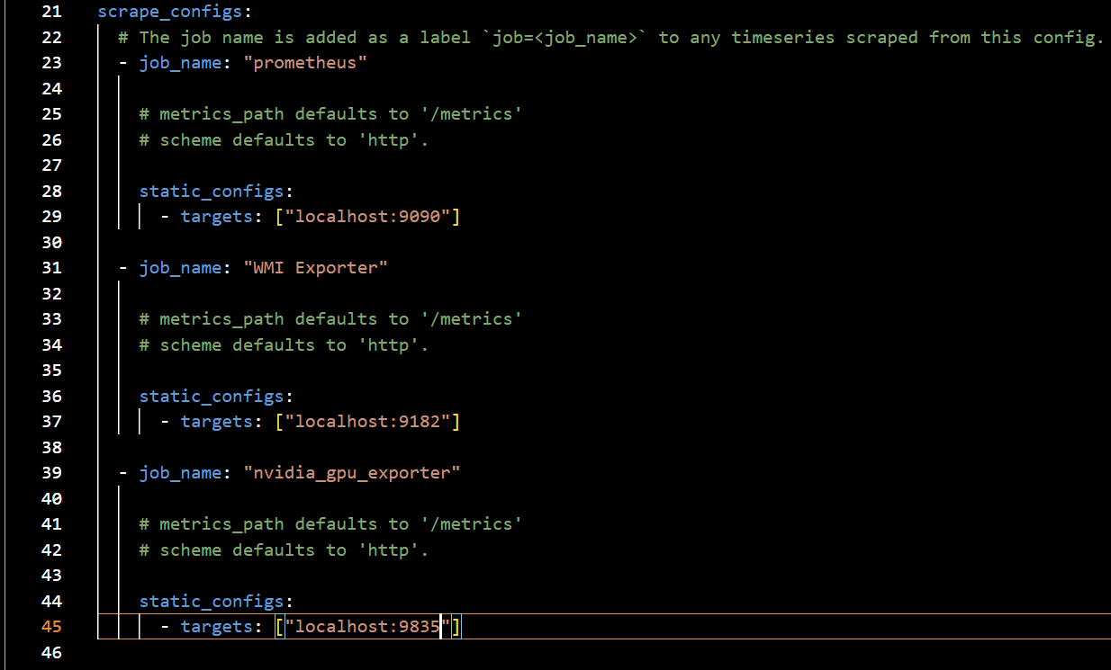



Restart the Prometheus service

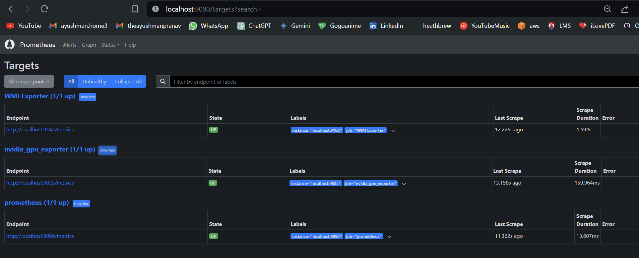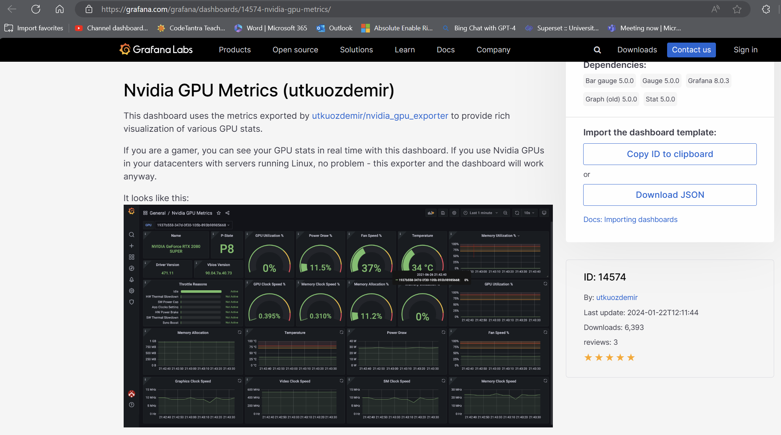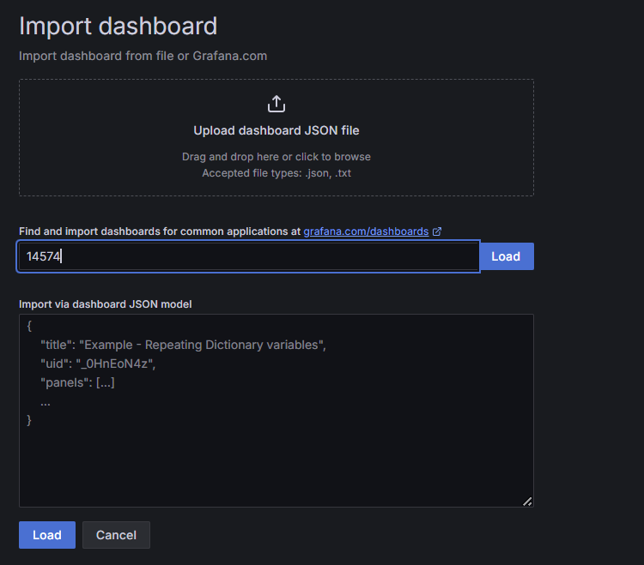

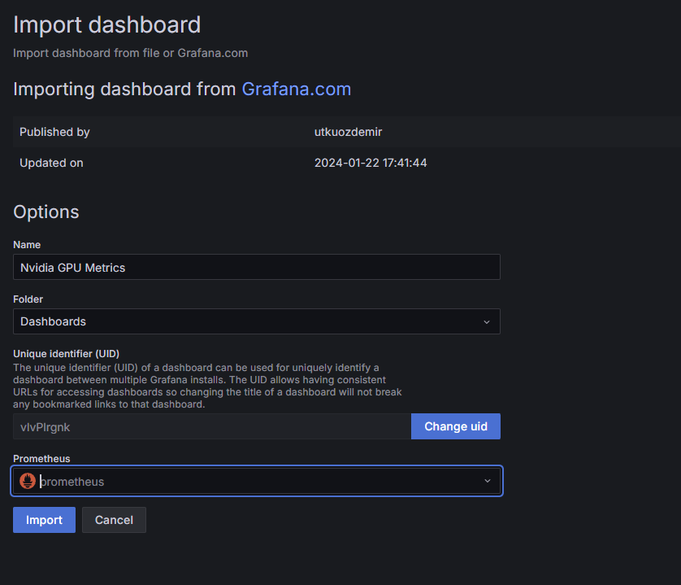

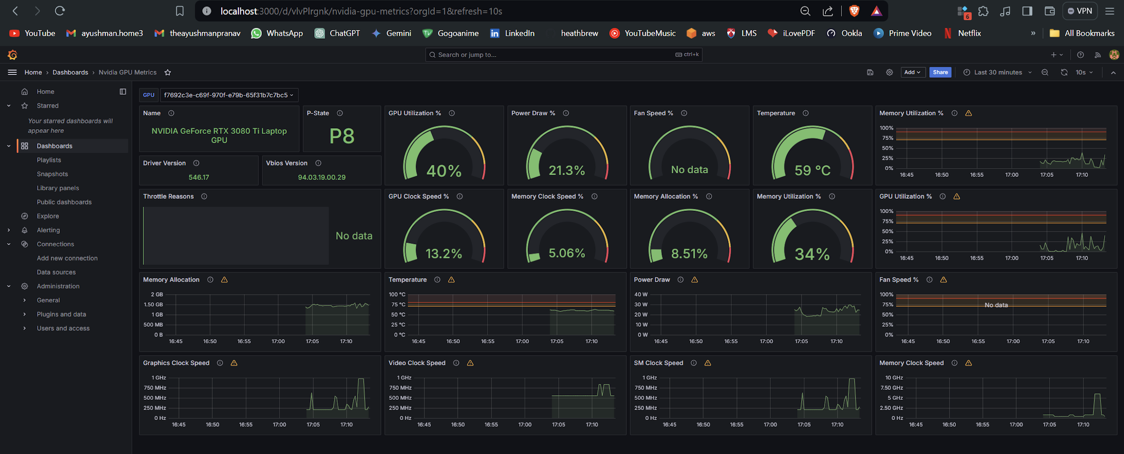

## Adding Qdrant metrics to Prometheus

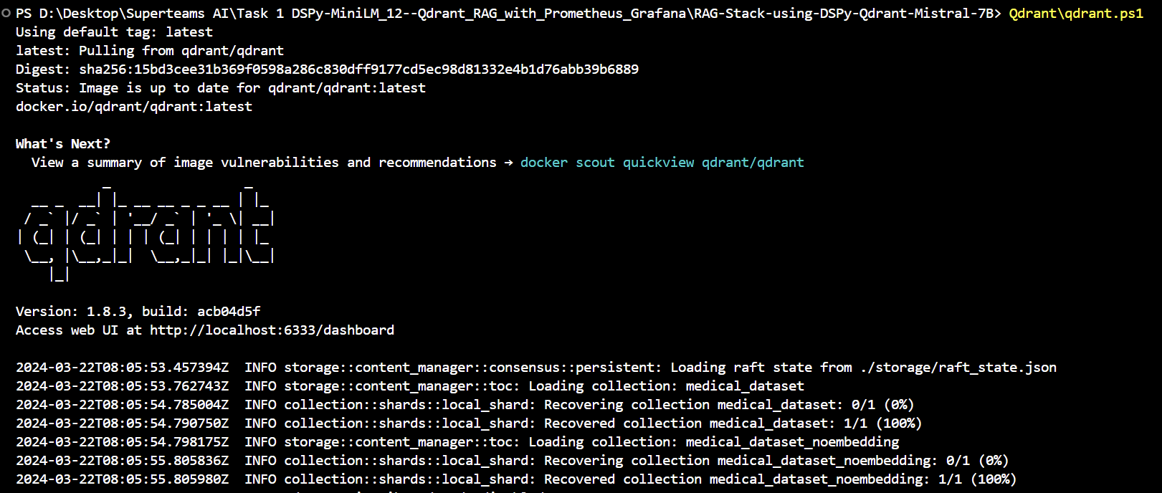

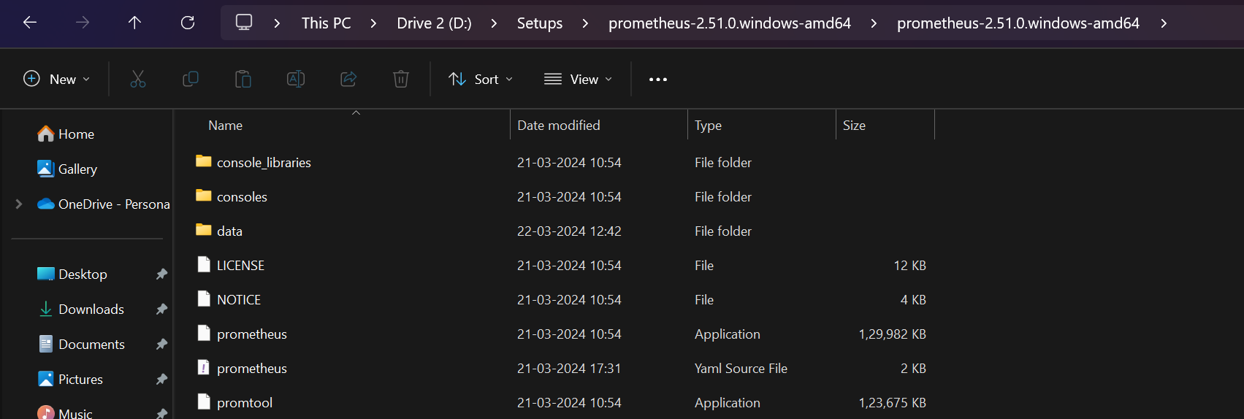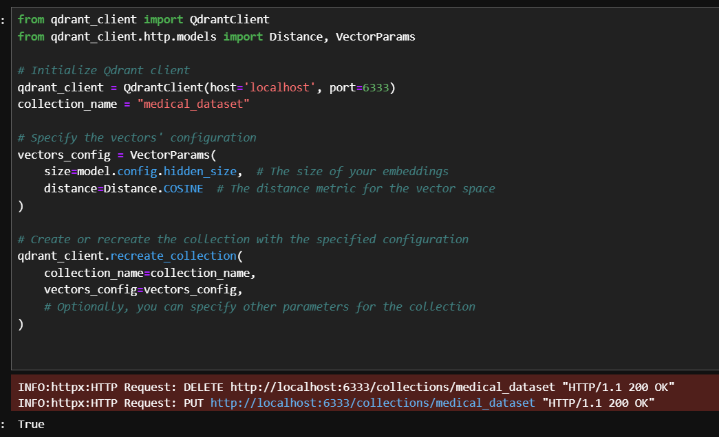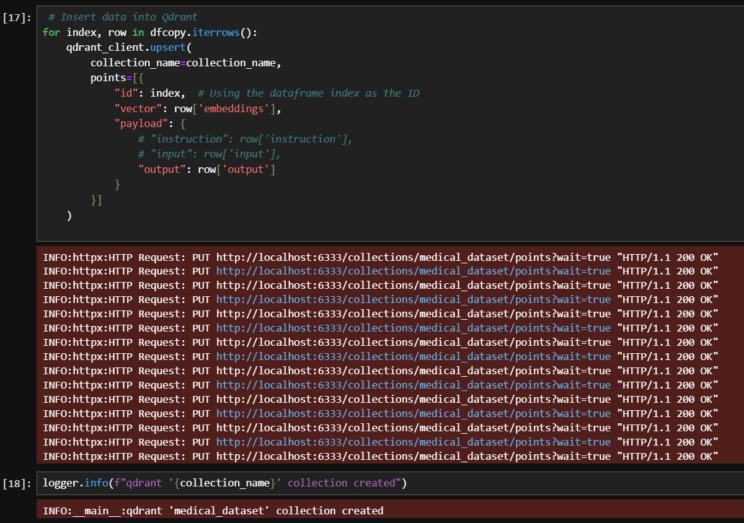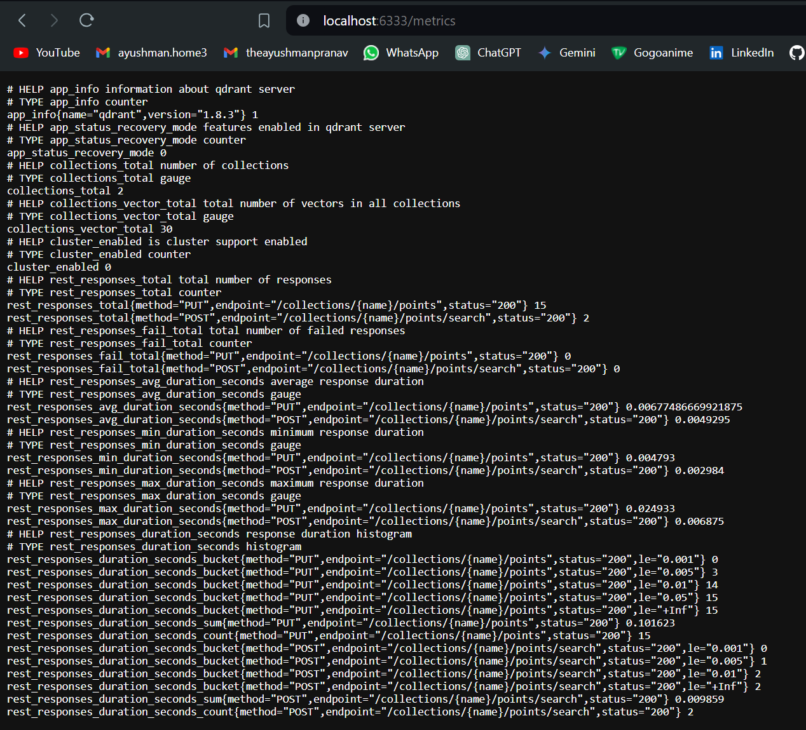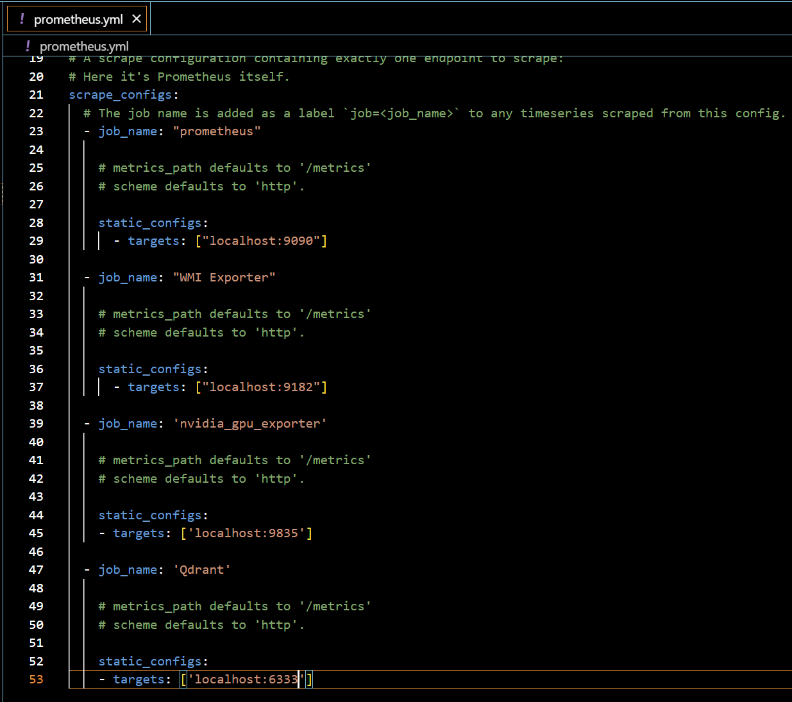****

**Restart the Prometheus service**

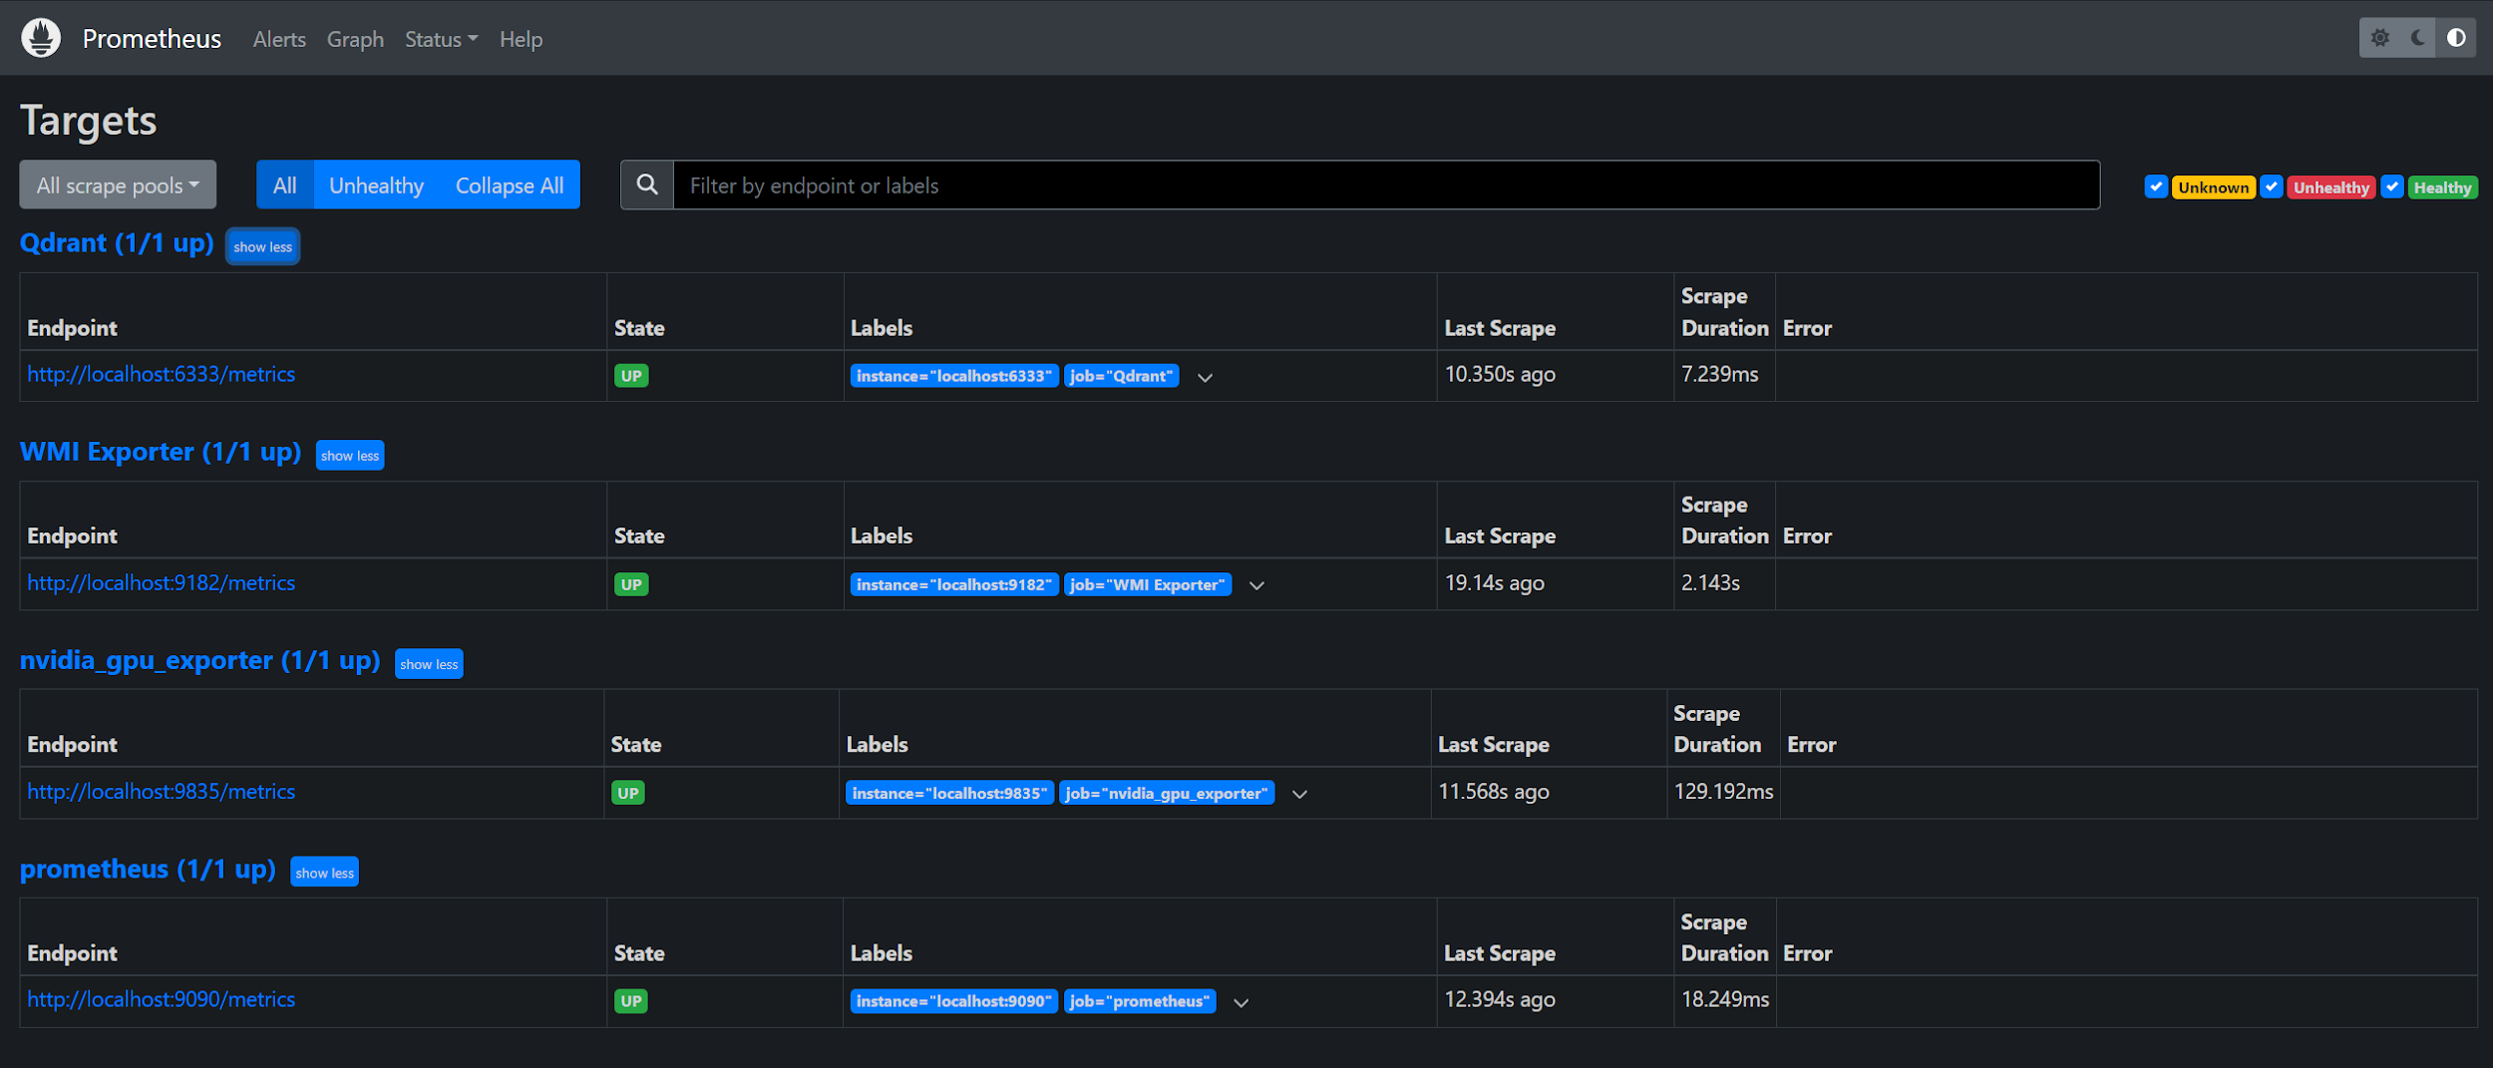

Click on New Dashboard

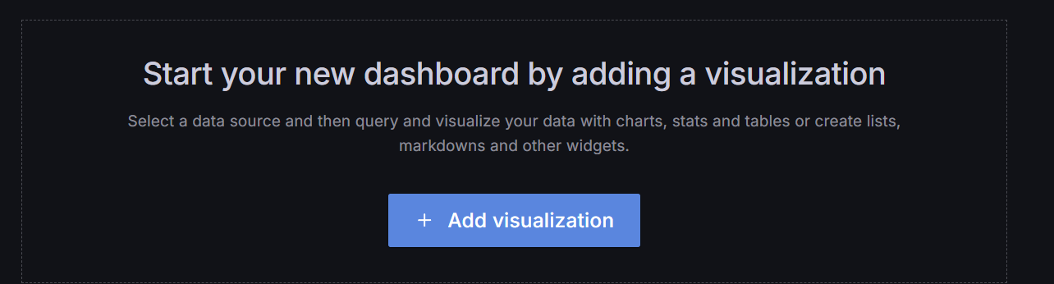

Choose Add Visualization

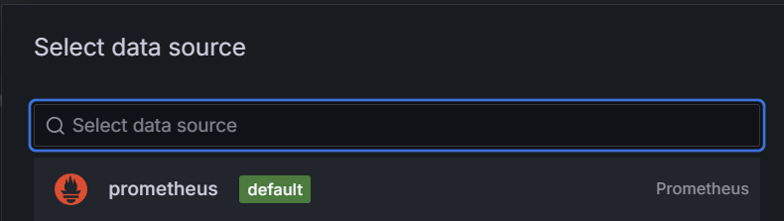

Start adding Promqueries

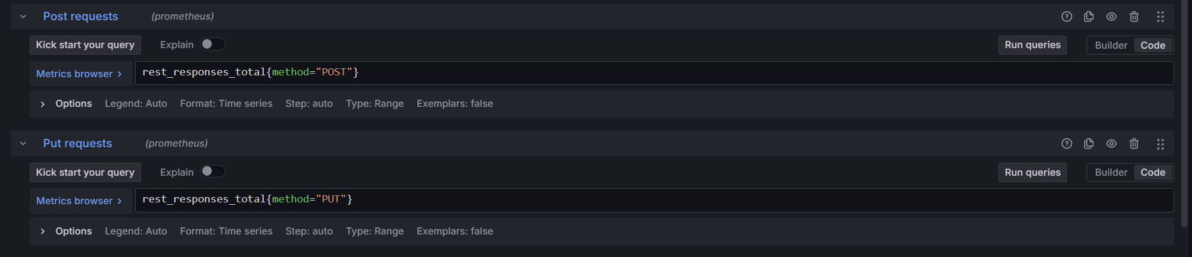

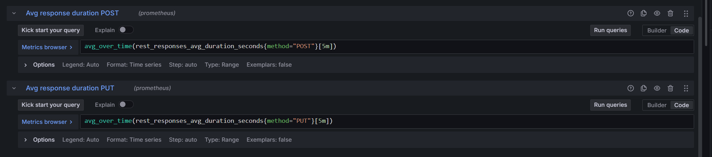

Choose Gauge as visualization for a better look.

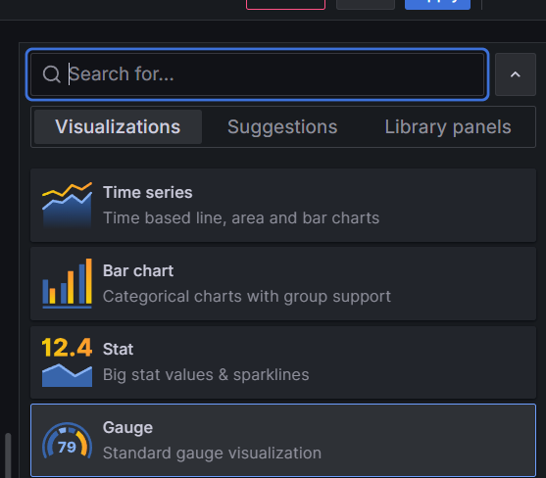

Or Stat works great to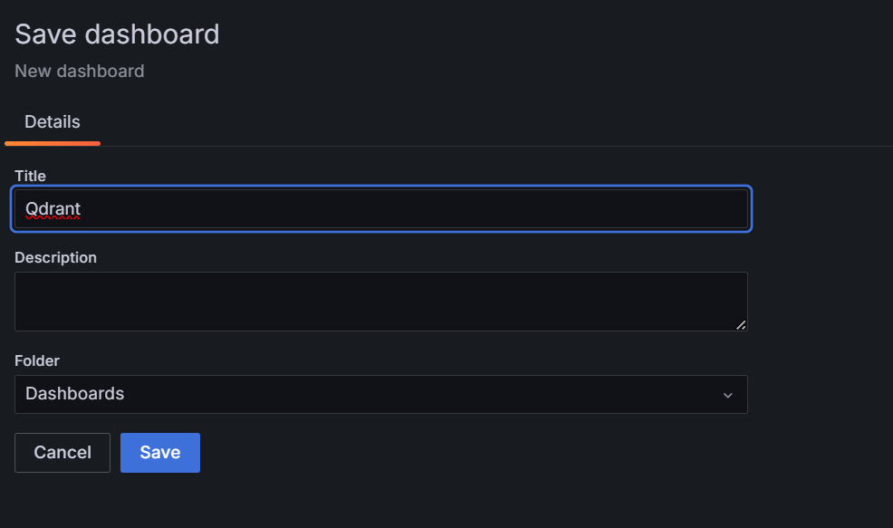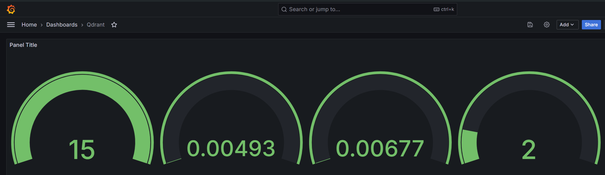

If you do some more customization, you get

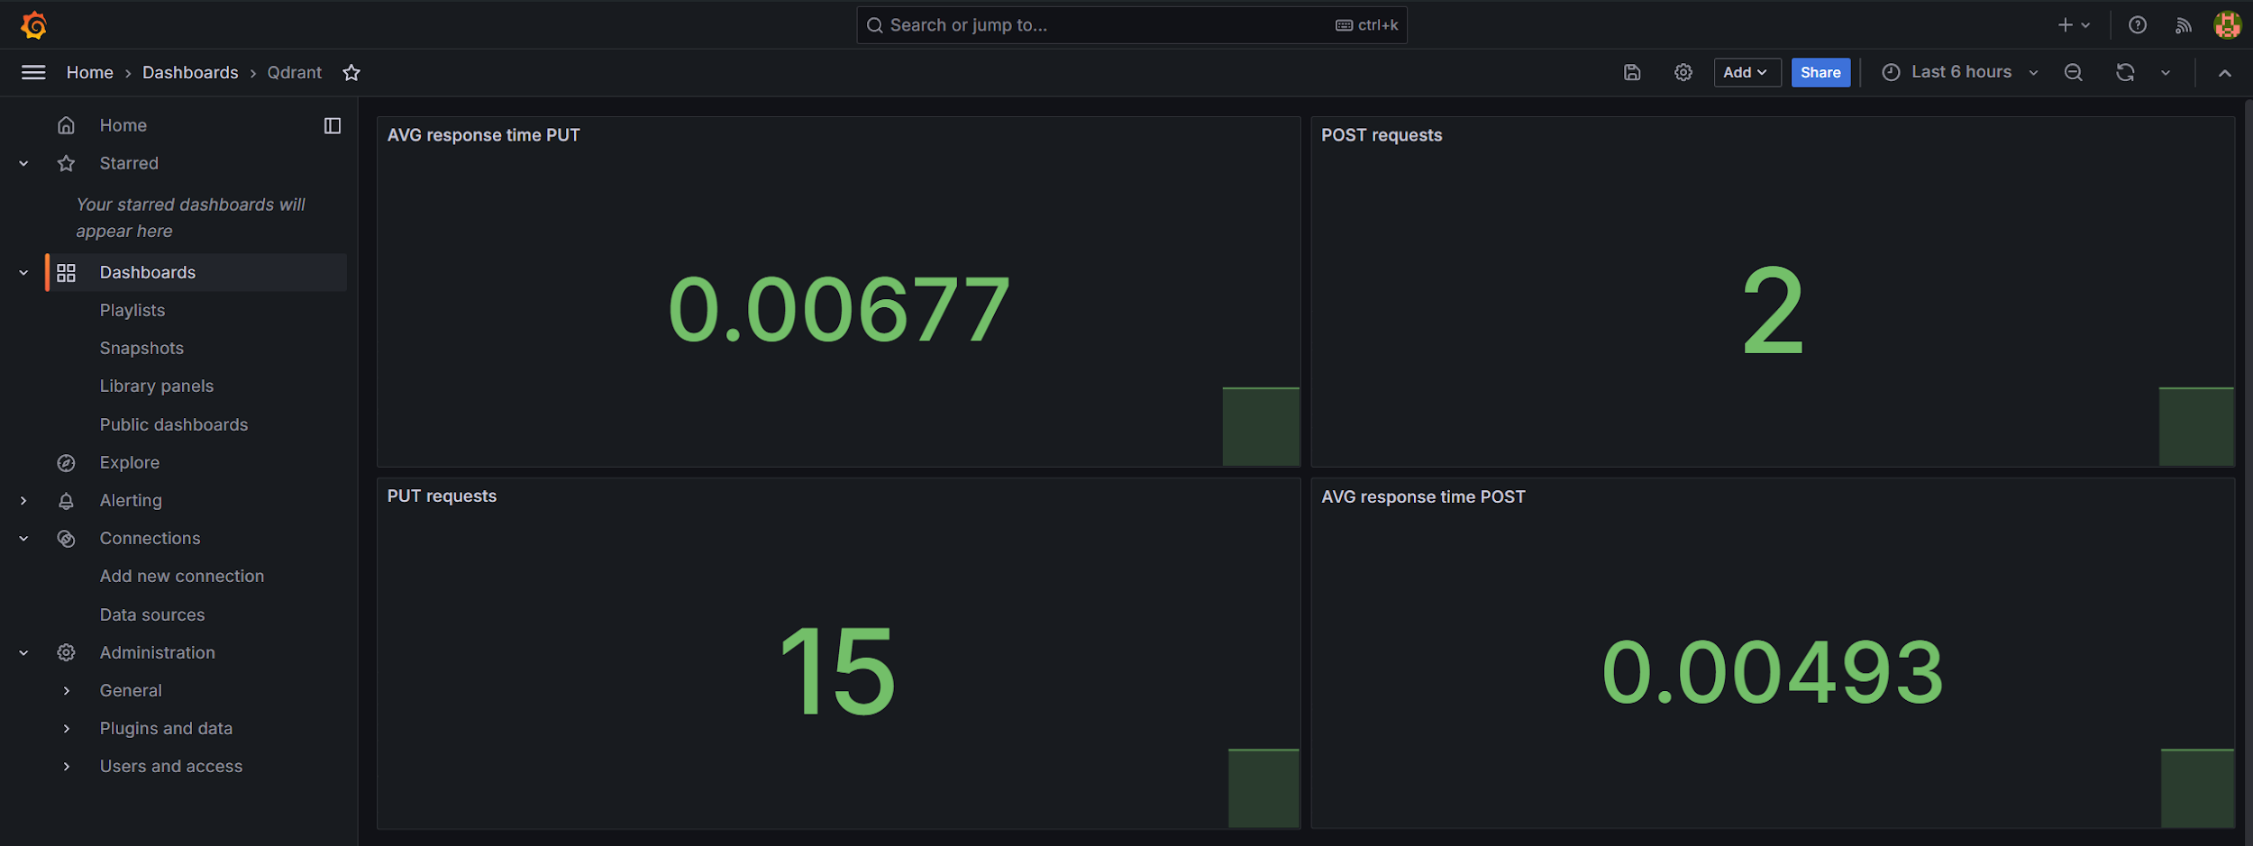

# Conclusion

In tracking ML workflows, Prometheus and Grafana stand out. They keep tabs on processes to ensure a smooth operation. This guide leads programmers to closely monitor custom embeddings in MiniLM V12 within a healthy Q&A flow that Qdrant oversees. By keenly watching data trends, one can quickly spot oddities. This careful watch boosts resource efficiency and enhances system output. Armed with these monitoring tools, companies can roll out ML models confidently, targeting enhanced outcomes in real-world applications.